TAXONOMIC COMPOSITION AND ECOLOGICAL ASPECTS OF JUVENILE ANGUILLID EELS IN THE SABAKI ESTUARY, KENYA

LENA MUTHONI GITONGA

A thesis submitted in partial fulfilment of the requirements for the Award of the Degree of Master of Science in Fisheries of Pwani University

JULY, 2023

DECLARATION

By the Candidate:
I declare that this thesis is my original work and has not been presented at any University or Institution for the award of a degree or any other academic purpose.
Lena Muthoni Gitonga
SG25/PU/36065/19 Signature Date
By the Supervisors:

This research thesis has been submitted with our approval as the supervisors.

Prof. Mlewa Chrisestom Mwatete

Pwani University Signature Date

Dr. Charles Kihia

Egerton University Signature Date

DEDICATION
This thesis is dedicated to my parents for their support and to Dr Charles Kihia who has held my hand and walked with me throughout my study career. Their support has kept my faith alive!

ACKNOWLEDGEMENT
I thank my supervisors; Prof. Mlewa Chrisestom Mwatete and Dr. Charles Kihia; for guidance and support from proposal development through to the writing of this thesis. I am very grateful to the academic input of Dr. Charles Kihia and Dr. Celine Hanzen who conceptualized and secured the project that funded my field and laboratory work. I also thank my field technicians; Mr. Roman Kazungu and Mr. Gira Mnyika Mbovu, for their assistance with the field work. I am grateful to the Western Indian Ocean Marine Sciences Association (WIOMSA) for funding my Master Degree program through the research project titled: ‘Slippery resource in peril: ecology of Western Indian Ocean Anguillid eels and their contribution to sustainable fisheries and livelihood along the east coast of Africa’, Kenya Marine and Fisheries Research Institute (KMFRI) for providing laboratory space and facilities. Finally, many thanks to the entire WIOMSA team Kenya and South Africa, for making the fieldwork not only educational but also enjoyable. I am forever indebted to you, thank you.

ABSTRACT
Eels of the genus Anguilla are catadromous and highly migratory species, which spawn in the sea and migrate to freshwater habitats via the estuary for feeding, growth and refugia. Of the 19 globally known anguillid eel species, four; Anguilla mossambica, Anguilla bengalensis, Anguilla marmorata and Anguilla bicolor, occur within the Western Indian Ocean. Juveniles of these species found within estuaries are referred to as glass eels and elvers. However, knowledge on their existence within Kenya estuaries is unknown. Juvenile anguillid eels were sampled monthly from July 2021 to January 2022, using glass eel fyke nets, deployed at the lower reaches of the Sabaki Estuary and specimen collected, examined using both morphological and morphometric characteristics.
A total of 76 glass eels and elvers, were collected during the six months of investigation with the biggest catch being in the month of August. Three species; A. mossambica, A. bengalensis and A. marmorata, were recognized to occur within the Sabaki Estuary. 87% of glass eels collected belonged to A. mossambica, A. bengalensis and A. marmorata species while 13% of elvers belonging to A. mossambica and A. bengalensis species. Species composition of glass eels comprised of A. bengalensis 76%, A. mossambica 21%, and A. marmorata 3% while those of elvers comprised of A. mossambica 80% and A. bengalensis 20%. Morphometric characteristics, (TL = total length, DF to AF =dorsal fin to anal fin, LED = left eye diameter and RED = right eye diameter) showed a pattern of similarity, with A. mossambica having the largest morphometric measurements followed by A. marmorata and lastly by A. bengalensis though variation observed were not statistically significant.
Differences in abundances of these juvenile anguillid eel species were explained by their monthly, seasonal (wet and dry), lunar phases and estuary sampling location. Temporal and spatial variability showed higher counts and relative abundance (%) of glass eels and elvers in the month of August 62% (n=) as well as the wet season n=53 (100%) and waning gibbous phase 100% (n=28%) of the lunar cycle. Higher abundance was also observed in sampling site SBE1 most proximate to the estuary 32% (n=24), followed by SBE4 30% (n=23) and SBE3 24% (n=18) while SBE2 14% (n=11) exhibited lower abundance of juvenile anguillid eels caught in the Sabaki Estuary. River discharge showed higher discharge flow rates observed at sampling site SBE2 and SBE3, 11 m3/s and 10 m3/s respectively while lower discharge flow was observed at most downstream and upstream sampling sites SBE1 and SBE4 at 0 m3/s and 1 m3/s respectively
Keywords: Anguillid, Glass eels, elvers, tail pigmentation, Sabaki Estuary, occurrence

TABLE OF CONTENT
DECLARATION i
DEDICATION iii
ACKNOWLEDGEMENT iv
ABSTRACT v
LIST OF TABLES viii
LIST OF FIGURES xi
CHAPTER ONE 1
1.0 INTRODUCTION 1
1.1 Background Information 1
1.2 Problem Statement 4
1.3 Justification 6
1.4 Objectives of the Study 7
1.5 Research Questions 8
CHAPTER TWO 9
2.0 Literature Review 9
2.1 Biology of anguillid eels 9
2.2 Oceanic migration and spawning of anguillid eels 11
2.3 Upstream migration 12
2.4 Factors influencing the occurrence of juvenile anguillids 13
CHAPTER THREE 16
3.0 MATERIALS AND METHODS 16
3.1 Study area 16
3.2 Sampling design and data collection 19
3.3 Data analyses 23
CHAPTER FOUR 25
4.0 RESULTS 25
4.1 Species composition and relative abundance of fishes caught in the Sabaki Estuary 25
4.2 Species composition and life stages of juvenile anguillid eels caught in the Sabaki Estuary 28
4.3 Morphometrics of juvenile anguillid eels 28
4.4 Influence of temporal and spatial variability of juvenile anguillid eels caught in the Sabaki Estuary 30
CHAPTER FIVE 40
5.0 DISCUSSION 40
CHAPTER SIX 46
6.0 CONCLUSION AND RECOMMENDATIONS 46
REFERENCE 47
APPENDICES 71
Appendix 1. Data sheet 71
Appendix 2. Revelliac et al., (2009) Species identification key for tropical juvenile anguillid eels……………………… 73
Appendix 3. Ege, (1939) Fin index identification key for tropical juvenile anguillid eels 74
Appendix 4. FDI for every individual captured 74

LIST OF TABLES
Table 1: Species composition of fishes caught by glass eel fyke nets from the Sabaki Estuary during the study 26
Table 2: Species total length and weight measurements of fishes caught in the Sabaki Estuary during the study 27
Table 3: Species composition of juvenile anguillid eels caught in the Sabaki Estuary. Values in parenthesis indicate relative abundance (%) of both glass eel and elver juvenile anguillid eel life stages 28
Table 4: Comparison of morphometric characteristics (TL= total length, DF to AF= dorsal fin to anal fin, LED= left eye diameter, RED= right eye diameter) (Mean ± SE) of juvenile anguillid species occurring in the Sabaki Estuary 30
Table 5: Species monthly counts and relative abundance (%) of juvenile anguillid eels caught in the Sabaki Estuary 31
Table 6: Relative abundance (%) and monthly counts of life stages of juvenile anguillid eel species caught across sampling months 31
Table 7: Relative abundance (%) of juvenile anguillid eel species caught in different lunar phases in the Sabaki Estuary 34
Table 8: Relative abundance (%) and lunar counts of juvenile anguillid eels caught during the study 35
Table 9: Relative abundance (%) and counts of juvenile anguillid eel species caught from sampling site SBE1-SBE4 in Sabaki Estuary 36
Table 10: Mean total lengths (Mean ± SD) of juvenile anguillid eel species caught across four sampling sites: SBE1, SBE2, SBE3, and SBE4 in Sabaki Estuary 37
Table 11: Mean total lengths (Mean ± SD) of juvenile anguillid eel species caught across four sampling sites: SBE1, SBE2, SBE3, and SBE4 in Sabaki Estuary 38
Table 12: Variations of discharge flow rates (m³/s) across four sampling sites: SBE1, SBE2, SBE3, and SBE4 in Sabaki Estuary 39
Table 13: Species composition of juvenile anguillid eels caught at varrying discharge flow rates (m³/s) in the Sabaki Estuary 40

LIST OF FIGURES
Figure 1: Life cycle of anguillid eels (source Cresci et al., 2019) 9
Figure 2: A photograph of the Sabaki Estuary taken during the low tide (Photo by Gitonga 2021) 17
Figure 3: A map of Kenya (inset) showing the Sabaki Estuary and sampling station SBE1, SBE2, SBE3 and SBE4 marked in red 18
Figure 4: Photograph of (A) glass eel and (B) elver specimen after preservation in ethanol, caught in the Sabaki Estuary (Photo by Gitonga, 2021) 21
Figure 5: Laboratory identification of juvenile anguillid eels (Photo by Gitonga, 2021) 22
Figure 6: Caudal fin and tail pigmentation patterns of glass eels (A) A. bengalensis, (B) A. mossambica and (C) A. marmorata taken by Stemi 305, Carl Zeis microscope GmbH, Germany using ZEN imaging software at x 2 magnification respectively 22
Figure 7: Total length (TL) measurements of juvenile anguillid eel species caught from sampling site SBE1, SBE2, SBE3 and SBE4 38

LIST OF ABBREVIATIONS AND ACRONYMS
AF Anal Fin
BMU Beach Management Unit
DF Dorsal Fin
EACC East African Coastal Current
ETT Ebb Tidal Transport
FDI Fin Difference Index
FTT Flood Tide Transport
GPS Global Positioning System
IUCN International Union for Conservation of Nature
LED Left Eye Diameter
LT Least Concern
NEM Northeast Monsoon
NT Near Threatened
RED Right Eye Diameter
SEM Southeast Monsoon
STST Selective Tidal Stream Transport
SWIO South Western Indian Ocean
WIO Western Indian Ocean

CHAPTER ONE

INTRODUCTION

Background Information
Estuaries are regions where saline water from the sea and freshwater from rivers, land run-off or seepage meet and mix (Conley et al., 2000; Whitfield et al., 2019). Estuaries are considered one of the most important fisheries ecosystems with high productivity (Elliott et al., 2007; Whitfield et al., 2019). Estuaries provides a transient habitat to a variety of diadromous organisms including fish species that migrate between freshwater and marine habitats in response to breeding, feeding and refugia needs, during different stages of their life cycle (Iguchi and Mizuno, 1999; Lytle and Poff, 2004; Mkare et al., 2014; Whitfield et al., 2019). There are three main types of diadromous fish: catadromous, anadromous, and amphidromous. Anadromous fish, such as salmon (Oncorhynchus spp), spend most of their lives in the ocean, but migrate to freshwater habitats to spawn (Huber et al., 2011). Amphidromous fish, such as gobies (Gobiidae spp.) life cycle involves downstream migration to the ocean soon after hatching, where they begin feeding and growth, subsequent to migrating upstream into freshwater for reproduction (Iguchi and Mizuno, 1999; Keith, 2002). Catadromous fish spend most of their lives in freshwater habitats but migrate to the ocean to spawn, among these are freshwater anguillids (Arai et al., 2002; Arai, 2015; Arai et al., 2020; Hanzen et al.,2019).
Anguillids undertake long-distance migrations from their oceanic breeding sites through estuaries into rivers where they grow and mature, then migrate back into the ocean to breed and die (Miller et al., 2018). Anguillid eels have six life cycle stages: egg, leptocephalus larvae, glass, elver, yellow, and silver eel (Arai et al., 2002). The life history stage that recruits from the sea to live in the freshwater environment is the earlier juvenile stage known as the glass eel (Jellyman and Lambert, 2003). Glass eels are the transparent juvenile eels that are virtually colourless upon arrival into the estuary (Arai, 2015). Glass eels recruit in two distinct phases; migration from the sea into estuaries, called inshore migration, and migration from estuaries into rivers, referred to as upstream migration (Arai et al., 2020). After their recruitment characterized by invasion into the estuary, glass eels develop body pigmentation, stop at the lower reaches of the river for a few weeks then metamorphosize into their next juvenile stage, referred to as elvers, which then proceeds to migrate upstream (Dekker et al., 2003; Robinet et al., 2003). Glass eels and elvers are the juvenile stages of anguillid eels found within estuaries. However, not all anguillid eels display upstream migration, certain temperate anguillid species such as A. rostrata exhibit facultative catadromy completing their life cycle within estuaries (Tsukamoto, 2009; Arai and Siti, 2016)
Globally, there are 19 species in the genus Anguilla, (Arai et al., 2020; Hanzen et al., 2019). In the Western Indian Ocean (WIO), four species have been identified, including; The African longfin eel, Anguilla mossambica (Peters 1852); Indian mottled eel, A. bengalensis (Gary 1831); Giant mottled eel, A. marmorata, Quoy and Gaimard 1824 and Indonesian shortfin eel, A. bicolor McClelland 1844 (Ege, 1939; Miller et al., 2018; Froese and Pauly, 2019). Anguilla marmorata is the most widely distributed in the world (Hanzen et al., 2020) and occurs from the southern Cape region of South Africa to the east African coast through the Indo-Pacific to the Mid-Pacific islands (Jacoby and Gollock, 2014; Robinet et al., 2008;). Anguilla mossambica is endemic to the Agulhas current region of the Indian Ocean, stretching from Kenya to the southern cape of South Africa (Hanzen et al., 2019). A. bicolor is widespread in the Indo-pacific region occurring from Australia, India, Sri Lanka, Bangladesh, the Malaysian Peninsula, the Arabian Peninsula, the east coast of Africa, the tropical Indian Ocean islands and the Arabian Peninsula (Jacoby et al., 2014). In the WIO, A. bengalensis is considered most widespread and has been reported from north of the Limpopo River in South Africa to Kenya as well as Ethiopia with further diverse range including India, Ceylon, Sandoway, the coasts of Burma, the Andamans and Serdang, the west coast of North Sumatra and Peninsular Malaysia (Arai, 2015; Hanzen et al., 2020).
Although recruitment patterns of anguillid eels into tropical freshwater systems remain poorly known, it is thought to be similar to that of temperate eel species (Robinet et al., 2003; Gagnaire et al., 2007). The duration of recruitment of juvenile anguillid eels into the estuary range from months to almost a year depending on the species and/or the site (Tsukamoto et al., 2002; Arai et al., 2016). For instance, studies from Réunion Island rivers indicated that recruitment of tropical glass eels only occurred 5 months in a year, between the months of November and March with differences among species (Robinet et al., 2003; Arai et al., 2016). In that study, A. bengalensis recruitment peaked between January and March, A. marmorata in January and February, A mossambica from November to December and A. bicolor in March (Robinet et al., 2003). In contrast, recruitment of A. celebesensis, A marmorata and A. bicolor in the western Pacific Ocean in North Suluwesi, Indonesia was reported to occur all year-round (Arai et al., 2016).
For instance, tropical glass eels have been documented to exhibit recruitment preferences influenced by months (Robinet et al., 2003; Arai et al., 2016), lunar phases (Sugeha et al., 2001), as well geographic distribution (Robinnet et al., 2007; Réveillac et al., 2009). Recruitment preference of these factors by juvenile anguillid eels can be attributed to favourable conditions necessary for their growth and movement, resulting in higher abundance.
First record on the existence of Anguilla spp in Kenya rivers by Frost, (cited in Van Someren and Whitehead, 1959) highlighted the presence of three adult species A. bengalensis, A. bicolor and A. mossambica. In the report A. bengalensis was documented to be the most abundant above 3,000 ft, A. mossambica was described as comparatively rare while A. bicolor was reported to be uncommon and restricted to the lower reaches of rivers (Van Someren and Whitehead, 1959). There are only two documented occurrences of juvenile anguillid eels in Kenya rivers (Van Someren and Whitehead, 1959). In April 1958, a total of 18 elvers captured, in the syphon-priming chamber of the Tana River dam, were identified as A. bengalensis. Although captured during their upstream migration, clear information regarding their arrival at the mouth of the Tana River remains unknown. Nonetheless, recorded on their total lengths indicate that they were likely in a post-elver stage (Van Someren and Whitehead, 1959).
A small A. mossambica elver measuring 8.75cm is recorded to have been caught using a traditional basket trap at Jilore, located along the Sabaki River, 32 km away from the sea (Van Someren and Whitehead, 1959). Despite uncertainty surrounding the date of capture, it is conjectured that the eel was captured during the November 1956 floods, which coincide with the short rain season. These two documented occurrences of elvers, in the Tana and Sabaki rivers are the first and only verified records of juvenile anguillids in Kenya (Van Someren and Whitehead, 1959).
With scarcity of studies documented on anguillid eels and their juveniles in Kenyan rivers, this group requires attention and hence this study. This is of concern since according to the ICUN Red list of species, A. mossambica (Hanssens and Snoeks, 2010), A bengalensis (Engelbrecht et al., 2010), A. bicolor (Jacoby et al., 2014; Pike et al., 2019a) conservation status have recently been listed upgraded to Near Threatened (NT) not excluding A. marmorata classified as Least Concern (LC) (Pike et al., 2019b; Itakura et al., 2020). Given the absence of pertinent data, it is thereby, important to accurately determine the anguillid recruitment patterns into the estuaries of Kenya, in order to subsequently guide development of management strategies this fishery.
Therefore, the aim of this study was to ascertain the occurrence and abundance of juvenile anguillid eels within the Sabaki Estuary, with the goal of providing baseline scientific data on the ecology and biology of eels WIO rivers.

Problem Statement
The life history of anguillid is marked by the movement of adults from freshwater environments to reproduce in oceanic habitats, while their larvae and young individuals traverse estuaries enroute to upstream freshwater habitats for nourishment and development. Nevertheless, remarkably little is known on the occurrence, population and ecology of tropical juvenile anguillid eels in the Western Indian Ocean region and Kenya. Although there are early records (1959) of juvenile anguillid occurrence in Kenyan rivers, more recent comprehensive description of their taxonomic diversity, life stages, distribution, and biology in the face of post 1960 river modification and fishery, are lacking. Furthermore, although the four species of anguillid species are expected to occur in Kenyan estuaries, threats to their survival proliferate and are a source of significant concern as evidenced by recent upgrading of 3 of the 4 species.
Spatial and temporal arrangement of juvenile anguillid eel populations within freshwater ecosystems can be ruled by a variety of distinct factors. For instance; physical barriers such as dams and weirs; ecological factors e.g. lunar influence as well as hydrological regimes which encompass elements like river flow, plays a significant role in determining the distribution and abundance of juvenile anguillid eels. Thereby, while spatial and temporal influence of some of these factors on the occurrence and recruitment of tropical juvenile anguillid eels have been described, influence of the same within in the Sabaki Estuary is currently unknown.

Justification
Anguillid eels are the only long-distance catadromous species in the Western Indian Ocean region (Hanzen et al., 2020). With few studies on the existence of tropical juvenile anguillid eels in Kenya estuaries (Van Someren and Whitehead, 1959), further research is necessary to substantiate the existence of anguillid eels in Kenya as well as gain a better understanding on their occurrence, distribution and abundance in this essential ecosystem. Their identification and documentation within Kenya estuaries will in turn result in the establishment of a reference database for reference hence subsequently open various avenues for further research.
Anguillid eels are a flagship and good indicators species (Hanzen et al., 2020; ICUN, 2016) for freshwater biodiversity, where they play a key role in identifying areas of ecological value, impacts of anthropogenic disturbances and monitoring population trends of other species (Hanzen et al., 2020; Itakura et al., 2020; ICUN, 2016). However, three species tropical anguillid eels have been categorized as "Near Threatened’ by the ICUN Red list of species (ICUN, 2019), this has significant implications for other freshwater and marine aquatic species (Itakura et al., 2020; ICUN, 2016). Considering their catadromous habitat use extending from marine to freshwater ecosystems, anguillid eels have significant advantages in understanding the composition, state and function of other aquatic flora and fauna (ICUN, 2016). This, in turn, is beneficial for the conservation and management of natural ecosystems.
Influence of temporal and spatial parameter on the occurrence of juvenile anguillid eels play a crucial role in understanding their distribution patterns and abundance within the Sabaki Estuary.
Thereby, understanding these factors and their influence on the occurrence and abundance of juvenile anguillid eels in the Sabaki Estuary is essential for establishing effective management strategies and conservation strategies aimed at protecting and preserving the anguillid eel population in the Sabaki Estuary.

Objectives of the Study
The overall objective of the present study was to gather and document baseline scientific information on juvenile anguillid eels in the Sabaki Estuary. The specific objectives of the study were:
- To determine the species composition of juvenile anguillid eels occurring in the Sabaki Estuary,
- To identify the developmental life stages of juvenile anguillid eels in the Sabaki Estuary,
- To determine temporal and spatial variation in the occurrence of juvenile anguillid eels in the Sabaki Estuary,

Research Questions
The study was guided by the following researchable questions:
- What is the species composition of juvenile anguillid eels occurring in the Sabaki Estuary?
- Which are the life stages of juvenile anguillid eels found within the Sabaki Estuary?
- Are there temporal and spatial differences in the numbers juvenile anguillid eels occurring in Sabaki Estuary?

CHAPTER TWO

Literature Review

Biology of anguillid eels
Eels are bony ray-finned fishes of the class Actinopteri, order Anguilliformes and family Anguillidae. Eels are highly migratory catadromous fishes with a fascinating life cycle, living part of their lives in both oceanic and freshwaters (Miller and Mc Cleave, 2018). Anguillid eels have a distinct life cycle (Figure I) which includes six stages; egg, the leptocephalus, glass eel, elver, yellow eel and silver eel stages (Arai et al., 2002).
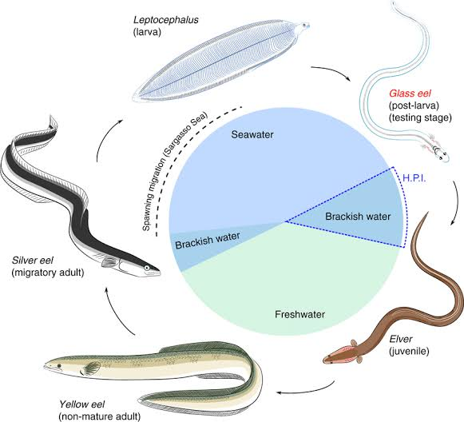
Figure 1: Life cycle of anguillid eels (source Cresci et al., 2019)
The early stage of the eel, the leptocephalus, is a distinctive larva with a laterally compressed and almost transparent body which primarily occurs in marine waters (Miller, 2009). From their spawning areas, leptocephali are transported by ocean currents to the continental shelf (Arai et al., 2016; Miller et al., 2018; Miller and Mc Cleave, 2018). Leptocephalus appear transparent in colour, mimicking gelatinous zooplankton, an adaptation to limit predation at sea (Miller et al., 2018; Miller and Mc Cleave, 2018). Before arrival at estuaries the nonfeeding leptocephali metamorphosize into transparent glass eels. Prior to inshore migration glass eels undergo metamorphosis, developing most organs such as intestine, gills and kidneys; as well as muscles and bones (Otake, 2003; Arai et al., 2016; Arai et al., 2020). Upon entry into the estuary glass eels alter their osmoregulatory system from one that eliminates excess salt and conserves water to the one where the reverse applies, so as to achieve homeostasis (Harrison et al., 2014).
At the stage of initial arrival in the estuary from the sea, glass eels are still almost completely transparent with no external pigmentation except a small rosette of pigment present around the top of the cranium (Strubberg, 1913; Arai, 2015). Ideally, glass eels carry out their migration into estuaries and then into fresh water (Dekker, 2002). Progressively, pigmentation darkens as the glass eels actively swim upstream transforming into elvers, four to eight months after sea hatching to grow in freshwater habitats (Dekker, 2002; Harrison et al., 2014). After ascending further upstream further as elvers, the subsequent growing phase is termed as yellow eel (immature) which belly appears yellow in colour and lives in freshwater habitats (Hagihara et al., 2012; Harrison et al., 2014). The yellow eel spends a minimum of 7 years to a maximum of 50 years depending on factors such as species, sex, and geographic location (Arai et al., 2016; Arai et al., 2020). The subsequent life stage from yellow eel is referred to as the silver eel. During the metamorphosis of yellow eels to silver eels, the ventral side of the body becomes more, whiter and reflective, their gonads develop, and their eyes increase in diameter by approximately 50% (Okamura et al., 2007). This metamorphosis coincides with the initiation of their downstream migration towards the marine habitat, where they ultimately reach the spawning grounds and subsequently die (Harrison et al., 2014; Arai, 2015). However, the silver eel migration period is one of the life stages remains the least understood, with knowledge of migration route and behaviour being speculative (Okamura et al., 2007; Harrison et al., 2014).

Oceanic migration and spawning of anguillid eels
Temperate anguillid eels are characterized by clearly defined, spawning and recruiting seasons (Tsukamoto, 2009; Robinet et al., 2003; Pous et al., 2010; Arai and Siti, 2016; Shirotori et al., 2016). The spawning migration of temperate anguillid eels generally occurs during autumn months between August and December in the Northern Hemisphere and between February and May in the Southern Hemisphere, except in a case of the prolonged downstream migration activity between April and December however with high temporal variation is observed in north eastern Germany with the European eel (Tsukamoto, 2009; Trancart et al., 2012; Arai and Siti, 2016; Cresci, 2020). All four tropical anguillid eel species share a similar spawning area located east of Madagascar and south west of Sumatra in the western Indian Ocean (Jespersen, 1942; Hanzen et al., 2020). However, according to Pous et al. (2010), tropical anguillid eels have different spawning areas closely linked through migratory routes to their recruitment sites.
Anguilla mossambica is thought to breed east of Madagascar but moves southwest on the way to the Mozambique coast and South African rivers, where their leptocephali are then transported southwards by the South Equatorial Current (SEC) with migration distances in the order of 1,000 to 2,000 km (Réveillac et al., 2009). A study by Jubb, (1961) showed that juvenile of A. mossambica reach the mainland coast between latitude 21°S at the border between Mozambique and Tanzania and 31°S southern coast of KwaZulu-Natal in South Africa. Another study states that their leptocephali are transported southwards by the South Equatorial Current (SEC) with migration distances in the order of 1,000 to 2,000 km (Réveillac et al., 2009; Whitfield et al., 2019)
Anguilla bicolor has two potential spawning area southwest of Sumatra (Jespersen, 1942; Arai et al., 1999) and northeast of Madagascar (Robinet and Feunteun, 2002; Robinet et al., 2008). Even though they reportedly occur in eastward flowing rivers of east Africa, the species has not been recorded in Kenyan rivers (Pike et al., 2019a). Glass eel, elvers and post-elvers of A bengalensis have been recorded to follow a northern migration route around Madagascar reaching the latitude 20°S. (Robinnet et al., 2007; Réveillac et al., 2009). According to Robinnet et al. (2007), A. marmorata has the widest distribution in the world and has been reported together with A mossambica in the islands of Mauritius and Réunion (Robinnet et al., 2007; Hanzen et al., 2019). Jespersen’s, (1942) hypothesized that the migration pattern of A. mossambica and A. marmorata larvae are through the southern tip of Madagascar.

Upstream migration of tropical eels
While the catadromous life cycle of anguillid eels show that they migrate between marine and freshwater habitats, some studies have documented that not all species of anguillid eels migrate upstream into freshwater habitats, but rather display facultative catadromy completing their life in estuarine habitats (Tsukamoto and Arai, 2001; Arai et al., 2013; Harrison et al., 2014; Harrison et al., 2014). Recent studies on otolith chemistry show that anguillid eels have more adaptable life histories than previously presumed (Tsukamoto et al., 2002; Chino and Arai, 2010; Arai and Chino, 2012). Anguillid eels have been reported to exhibit facultative catadromy by either migrating between rivers and estuarine habitats or migrating between seawater and estuarine habitats of multiple freshwater rivers (Hanzen, 2020; Harrison et al., 2014; Harrison et al., 2014).
The tendency of some juvenile anguillid eels to settle within estuaries rather than migrate upstream to freshwater habitats is thought to be influenced by internal drivers such as body conditions and endocrine control (Edeline et al., 2005; Edeline et al., 2006; Jensen et al., 2018). For instance, a glass eels energy content upon estuarine arrival would determine whether the individual will proceed migrating upstream or favour early settlement (Harrison et al., 2014). A study by Edeline et al. (2006) found that under experimental conditions, glass eels with lower body conditions preferred saline water as compared to freshwater, suggesting that in the wild the preference to saltwater induces early settlement.
In relation to endocrine control there is evidence of thyroid and cortisol hormone, stimulate migratory behaviour of juvenile anguillid eels (Edeline et al., 2005; Edeline et al., 2006; Harrison et al., 2014). Thyroid hormone is suggested to regulate the physiology and behaviour of juvenile anguillid eels leading to upstream migration (Edeline et al., 2005; Edeline et al., 2006; Edeline et al., 2009). Cortisol hormone on the other hand promotes the activity of Na and K ATPases in the gill and intestines of juvenile anguillid eels during salt water residency (Wilson et al., 2004). Additionally, the production of cortisol hormone is linked to a decrease in thyroid hormone production which in turn results to lower body condition upon estuarine arrival hence a shift from upstream migration to estuarine settlement (Wilson et al., 2004; Edeline et al., 2005; Edeline et al., 2006; Edeline et al., 2009; Harrison et al., 2014).
Studies on otolith microchemistry of temperate anguillid eels have also shown that, some yellow and silver stages, spend their entire life history in the ocean and never migrate into freshwaters (Arai et al., 2013). According to the migratory life history of A mossambica and A marmorata, otolith ratio of Strontium:Calcium ratios of sampled by Lin et al. (2012) from South African rivers, showed that after inshore migration as glass eels, elvers of both species resided in estuarine habitats awaiting favourable river flow conditions during the wet season in preparation for upstream migration. However, if the river flow is insufficient for upstream migration, elvers will most likely leave and travel along the coast in search of favourable habitats as an alternative option (Lin et al., 2012).
Facultative catadromy can be explained by estuarine habitats being able to provide a significant environment for feeding and rearing from their entry as glass eels to their escapement at silver eel life stage (Lin et al., 2012; Arai et al., 2013; Harrison et al., 2014). However, information on facultative catadromy has only been obtained for temperate anguillid eels and little is known about the utilization of environmental habitats by tropical anguillid eels in East African rivers (Hanzen et al., 2020; Arai et al., 2013).

Factors influencing the juvenile anguillids recruitment
Migration of juvenile anguillid eels is impacted by a wide range of threats which could be either physical, ecological or hydrological (David et al., 2015). It can be difficult for juvenile anguillid eels to undertake upstream migration when migration routes are obstructed by physical barriers such as dams and weirs. However, the ability of elvers to ascend natural and human-made barriers is documented in Kenya rivers. Elver’s have been reported to be trapped in the draft tube turbines of the Tana Hydro-electric Power Station in Tana River over 500 km from the sea (Van Someren and Whitehead, 1959; Hanzen et al., 2020). Overfishing also pose threats to juvenile anguillid eels. Although not reported for tropical species stocks of A. japonica have been reported to decline due to overfishing (Tatsukawa, 2003; Tsukamoto et al., 2009; Kaifu et al., 2021).
Inshore and upstream migration of juvenile anguillid eels is also influenced by several factors. For instance, monthly occurrence of juvenile anguillid eels have been reported to be influenced by environmental cues that include light intensity and turbidity (Pauly et al., 2000; Jellyman et al., 2003; Bureau Du Colombier et al., 2007; Adam et al., 2008; Lanzoni et al., 2022), lunar cycle and tidal amplitude (Laffaille et al., 2007), river flow and odor (Creutzberg, 1961; McCleave and Jellyman, 2002; Arribas et al., 2012), and water temperature (Gascuel et al., 1995; White and Knights, 1997). On the other hand, annual changes in juvenile anguillid occurrence are reported to be associated with factors relating to recruitment success, spawning area (Arai et al., 2016; Arai et al., 2020). These findings are mostly derived temperate juvenile anguillid eels but fewer from tropical eels (Arai et al., 2020).
Anguillid eels respond to physicochemical properties such as temperature and salinity during migration and spawning (Jenkins et al., 2010; Schabetsberger et al., 2016). For instance, a minimum dissolved oxygen concentration of 5 mg/L is documented to be ideal for nursery culture of glass eels, as juvenile eels cannot survive in oxygen concentrations below 2 mg/L (Cuvin et al., 2019). While temperature is a critical factor in the survival, feeding, and growth of fish species, affecting food passage, enzyme activity, and metabolic rate (Linton et al., 2007; Briand, 2009; Harrison et al., 2014). In the Philippines, tropical glass eels have been successfully reared in temperatures ranging from 19 to 30°C without any signs of temperature stress (Cuvin et al., 2019). Juveniles of A. marmorata are documented to be sensitive to low water temperature and have an optimal growth temperature of 27.6 °C (Luo et al., 2013). A study by (Arai et al., 2020) reported presence of A. bengalensis specimens in upstream locations with temperatures ranging from 23.6 to 28.1 °C. However, due to moderate temperatures being continuous year-round and lack identifiable seasons in the tropics, water temperature may not be a factor in tropical glass eels' inshore migration (Cuvin et al., 2019; Arai et al., 2020).
Inshore migration of glass eels is influenced by light intensity (Arai et al., 2020), as documented by Laffaille, (2007), light intensity plays a role in glass eel migration, showing an increase in migration activity in the dark during the first hour of darkness, during which they move closer to the surface as compared to activity during the day (Bardonnet et al., 2003; Laffaille, 2007). However, this variable is still debatable, since Bardonnet et al. (2005) reported that light intensity has no inﬂuence on glass eel migration. While studying upstream migration of temperate species of glass eels in the Waikato River in New Zealand, Jellyman, (1979) suggested that light has no influence on A. australis and A. dieffenbachii glass eels after observing that they migrated both during the day and night (Prouzet et al., 2009; Arai et al., 2020). Laffaille, (2007) observed glass eels shifted towards the bottom of the bed when light intensity was high and were most actively moving and abundant at the bottom where light intensity was lower. Similarly, experimented in an aquarium glass eels of A. japonica were observed to burrow in the sand during daytime (Dou and Tsukamoto, 2003).
A correlation between light and lunar cycle highlights that glass eels remain in much deeper water during the full moon attributed to the high light intensity at that lunar period. A study by Sugeha et al. (2001) in the Poigar estuary recorded fewer glass eels during the full moon and higher glass eels collected during the new moon as compared to the waxing and waning moons. Arai et al. (2020) reported both lunar and semilunar periodicity of inshore migration by glass eels, with high number of glass eels observed to recruit during the new moon phase as compared to the full moon phase. Thereby, high moonlight intensity does play a role in influencing both inshore and upstream migration. However, the lunar effect in highly turbid estuaries remains debatable (Harrison et al., 2014). Turbid conditions reduce light penetration thus limiting lunar influence on migrating juvenile anguillids. Additionally, high turbidity may decrease predation rates guaranteeing higher survival and successful upstream migration (Lunt and Smee, 2020).
River discharge has also been shown to significantly affect the abundance of juvenile anguillid eels. Juvenile anguillid eels tend to gather near the lower estuary banks during periods of high river flow, when the water is calmer (Livingston, 1997; Lytle and Poff; 2004; Selleslagh and Amara, 2008; Criales et al., 2011; Harrison et al., 2014). However, this behavior puts them at greater risk of predation and exploitation (Rall et al., 2010). Moreover, elevated river flows are associated with heightened concentrations of suspended sediments, resulting in higher turbidity, which in turn leads to a higher density of juvenile anguillid eels dispersed across the river channel (Crivelli et al., 2008; Bru et al., 2009; Criales et al., 2011; Harrison et al., 2014).
Along with the rheotactic effects of river flow on upstream migration, olfactory cues associated with freshwater have also been documented to play an important role in modulating inshore and upstream migration of juvenile anguillid eels (Tesch, 2003; Bru et al., 2009; Harrison et al., 2014). Freshwater odours are used firstly as directional cues which facilitate recruitment towards inland waters and secondly behavioural cues, facilitating increased swimming activity during selective tidal stream transport (STST) (McCleave and Jellyman, 2002; Tesch, 2003; Bru et al., 2009). This is aided by the well-developed good sense of smell, olfactory rosette and nasal cavity of both glass eels and elvers which are documented to be similar to those of other fish species (Tesch, 2003).

CHAPTER THREE

MATERIALS AND METHODS

Study area
The study was conducted in the Sabaki Estuary, which lies between longitude: 3.2ºS and latitude: 40.15ºE, The Sabaki Estuary is located 10 km north of Malindi town, occupying an area of approximately 250 ha (Abuodha, 1998; GOK, 2014). The Sabaki Estuary form the downstream reaches of the Athi-Galan-Sabaki (Athi) River. The Athi river is the second largest river in Kenya; which discharges its waters into the Indian Ocean, north of Malindi along the Kenya coastline, near the Malindi–Watamu reef complex (GOK, 2014; GOK, 2016; Marwik et al., 2014).
The Sabaki Estuary is made up of two main zones; an intertidal muddy area and a main tidal channel, both of which are subjected to seasonal tidal effects i.e. the spring and neap tides (Kitheka et al., 2015; Kapombe, 2016; Kitheka et al., 2016) whereby during each tidal cycle, seawater which is flushed out (Kitheka et al., 2016; Marwick et al., 2018). Additionally, during each tidal cycle, the estuary experiences alternating low and high waters with an average depth of 3 m (Kitheka, 2002; Kitheka et al., 2015; Kitheka et al., 2016). A photograph taken of the Sabaki Estuary during the study (Figure 2) depicts the nature of the estuary at low tide.
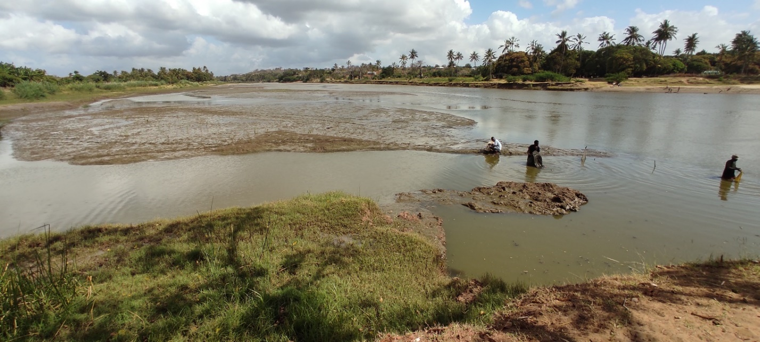
Figure 2: A photograph of the Sabaki Estuary during daytime low tide (Photo by Gitonga 2021)
The Sabaki Estuary experiences a tropical monsoon climate with two distinct rainfall seasons i.e. the short rain season, which is associated with the ‘Kaskazi’ or Northeast Monsoon (NEM) and the long rain season, which is associated with the ‘Kusi’ or Southeast Monsoon (SEM) season (McClanahan, 1998; Houte-Howe, 2005; GOK, 2008; Kitheka et al., 2013; GOK, 2014; Dzoga et al., 2018; Marwick et al., 2018). The short rain season occurs between the month of October and March, characterized by calm and warm sea water with and less rains, with the peak rainfall occurring in the month November (Kitheka et al., 2013; Kitheka et al., 2015). The long rain season occurs between the month of March and September and is characterized by rough and cool seas, more rains, stronger winds and lower temperatures, with peak rainfall in occurring in the month of April in the hinterland and May along the coast (Kitheka, 2013; Kitheka et al., 2015; Kitheka, 2016). Indicate major climate eg temp rainfall in Sabaki
The intertidal muddy area of the estuary is characterized by mudflats of dark brown clay and silt colonized by vegetation including mangrove trees (Kitheka, 2002; Kitheka et al., 2013; Kitheka et al., 2015). According to Kitheka et al. (2013) five mangrove species are known to occur in the Sabaki Estuary namely: Aviccenia marina (Forsk.) Vierh, Rhizophora mucronata Lam., Bruguiera gymnorrhiza (L.) Lam., Xylocarpus granatum Koenig, and Ceriops tagal C.B. Rob.
Artisanal fishers within the Sabaki Estuary employ traditional small dugout canoes, locally referred to as mtumbwi, hori, ngalawa and dau (Gobert, 1992; Hoorweg 2006; Hoorweg, 2009; Fulanda et al., 2011) and traditional fishing gears (McClanahan & Mangi, 2004; Hoorweg 2006; Hoorweg, 2009; Munga et al., 2014). Dominant fishing gears used in the estuary range from traditional traps such as malema basket traps, to modern gears such as tidal weirs or hand lines and long lines, as well as drift and gillnets (Gobert, 1992; Gobert; 1994; Hoorweg 2006; Hoorweg, 2009; Fulanda et al., 2011; Munga et al., 2016). However, majority of artisanal fishers in the estuary tend to fish more at the seaward side ﬁshing grounds (Malleret et al., 2007; Munga et al., 2012).
Fish species exploited by local artisanal fishers within the Sabaki Estuary include members of the families Protopteridae (lungﬁshes), Clariidae (catﬁshes), Cichlidae (tilapines) and several species of prawns such as Feneropenaeus indicus, Penaeus monodon, Penaeus semisulcatus, Penaeus japonicus and Metapenaeus monoceros (Okeyo, 2003; Linton et al., 2007; KMFRI , 2010; Fulanda et al., 2011; Mania, 2012; Munga et al., 2012; Munga et al., 2013; Munga et al., 2016). The Sabaki Estuary is also a bird sanctuary providing feeding and roosting sites for large numbers of gulls and terns, non-breeding Lesser Flamingos Phoeniconaias minor and some rarer species such as Broad-billed Sandpiper Limicola falcinellus (Hebert, 1998; Kitheka et al., 2013; Houte-Howes, 2005).

The study site was a section extending from the river mouth to approximately 2 km upstream. Four sampling locations were established approximately 0.5 km apart within the study site, one (SBE1) was located to the east of the Sabaki bridge and three of which (SBE2, SBE3 and SBE4) were located west of the Sabaki bridge (Figure 3). SBE1 located inshore at 3°09'11"S 40°07'40"E was the most downstream sampling station to the east of the Sabaki Bridge, approximately 1.5 km from the river mouth. SBE2 (3°08'52"S 40°07'28"E) was nearest to Sabaki Bridge and approximately 0.5 km from SBE1, while SBE3 (3°08'57"S 40°07'19"E) was located to the west of the Sabaki bridge approximately 0.5 km upstream of SBE2. SBE4 located upstream at 3°08'58"S 40°07'13"E was the most upstream, approximately 1 km west of Sabaki Bridge and 3 km from the river mouth. The selection of sampling sites was aimed at effectively representing three zones of the estuary i.e., downstream, midstream and upstream. Selection was also influenced by ease of accessibility and safety concerns as the Sabaki Estuary has a population of hippopotamus Hippopotamus amphibious, a large aggressive semiaquatic mammal (Kitheka et al., 2015).
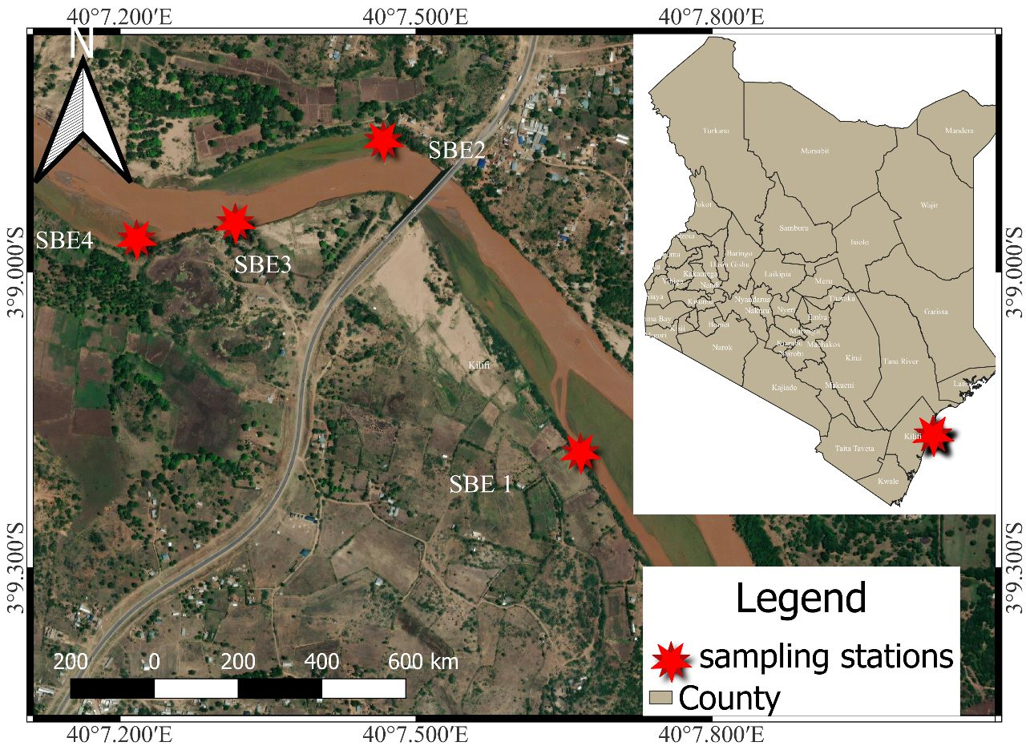
Figure 3: A map of Kenya (inset) showing location of the Sabaki Estuary and a digital map of the estuary with sampling stations (SBE1, SBE2, SBE3 and SBE4) indicated

Sampling design and data collection
Juvenile anguillid eels were caught using glass eel fyke nets of very fine 2mm mesh size, which are designed for commercial glass eel fisheries in Australia (T&L Netmaking, Mooroolbark, Australia). Sampling was conducted over a six-month period which encompassed five lunar phases i.e. full moon, waning gibbous, last quarter moon, first quarter moon, waning crescent moon, and new moon. Data on lunar phase as well as moonset and moonrise were obtained daily from the Vitalii (2019) software application and recorded in a data sheet (see Appendix 1).
Each month, sampling was conducted over a period of 5 consecutive days. During each sampling occasion and site, the estuary channel morphometry; width (m), depth (m), current velocity (m/s) and discharge (m3/s) variables were measured. River width and depth were estimated with a measuring tape and weighted graduated rope at a minimum of 5 points across the river at every reach location as described by Masese et al. (2014). River means current velocity was estimated in triplicate using timed drift across a known distance at every reach.
For each sampling occasion on the first day, one fyke net was deployed at every sampling station during low tide. Each fyke nets were set using poles anchored firmly into the substrate, with the wing end facing seaward and their position recorded using a Global Positioning System (GPS). The fyke nets were then checked in the early morning for retrieval of the catch. The catch of each fyke net was transferred to a labelled bucket containing water drawn from the estuary for later processing.
The contents of the bucket were then sieved through a 500 mm mesh net and the catch sorted according to species. Individuals belonging to each species were enumerated and recorded. All fish (except juvenile anguillid eels) were measured for total length (to the nearest 0.1 cm) on a fish length measuring board and weighed to the nearest 0.1g on an electronic top loading balance, while weight only for prawns (Penaeus indicus) were measured, on an electronic top loading balance to the nearest 0.1g. Juvenile anguillid eels caught total length was measured (to the nearest 0.1 cm) and categorized into glass eels and elver, based on external body pigmentation according to Robinet et al. (2003). Those without external body pigmentation classified as glass eels; while those with pigmentation were classified as elvers (Figure 4). Sampled juvenile anguillid eels were then stored in labelled sampling bottles and preserved in 99% absolute ethanol and transported to Kenya Marine Fisheries Research Institute (KEMFRI) laboratories for further morphological characterization, to species identification.
B

A

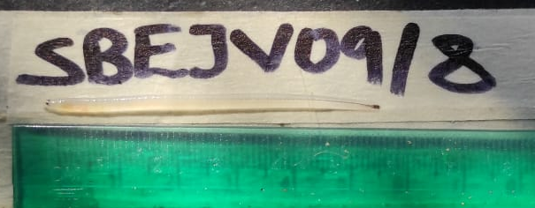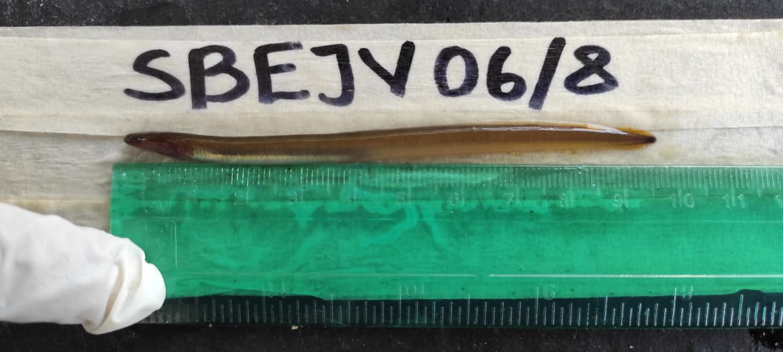
Figure 4: Photograph of (A) glass eel and (B) elver specimen after preservation in ethanol, caught in the Sabaki Estuary (Photo by Gitonga, 2021).
In the laboratory, juvenile anguillid eels were identified to species level by observing their tail pigmentation under a microscope (Stemi 305, Carl Zeiss Microscopy GmbH, Germany) at x 2 magnification for all glass eels and x 1 magnification for all elvers according to Revelliac et al. (2009) protocol (see Appendix 2) and individual photographs taken using ZEN imaging software (Carl Zeiss Microscopy GmbH) (Figure 5). The juvenile anguillid eel species sampled, belonged to 3 species A. bengalensis, A. mossambica and A. marmorata (Figure 6). Eye diameter recorded as left eye diameter (LED) and right eye diameter (RED) together with fin difference index (FDI), which is the distance between the dorsal fin (DF) to the anal fin (AF) (see Appendix 3), were measured in micrometres µm, under a microscope using ZEN software at x 2 magnification for all glass eels and x 1 magnification for all elvers. All morphometrics were recorded in a data sheet (Appendix 1).

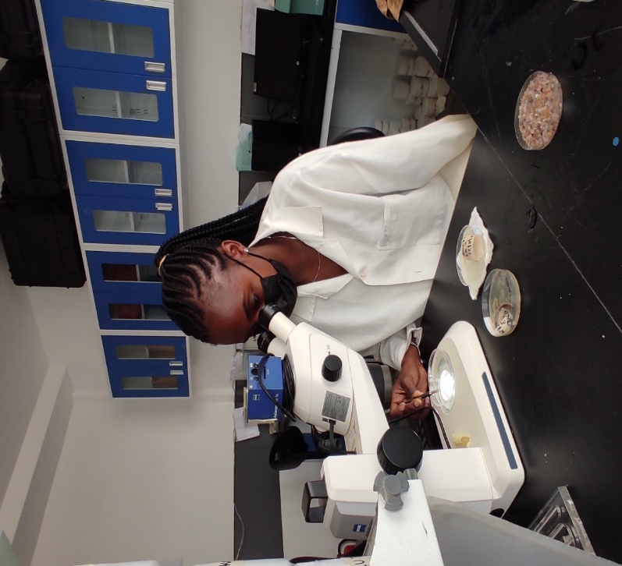
Figure 5: Laboratory identification of juvenile anguillid eels (Photo by Gitonga, 2021)
B

A

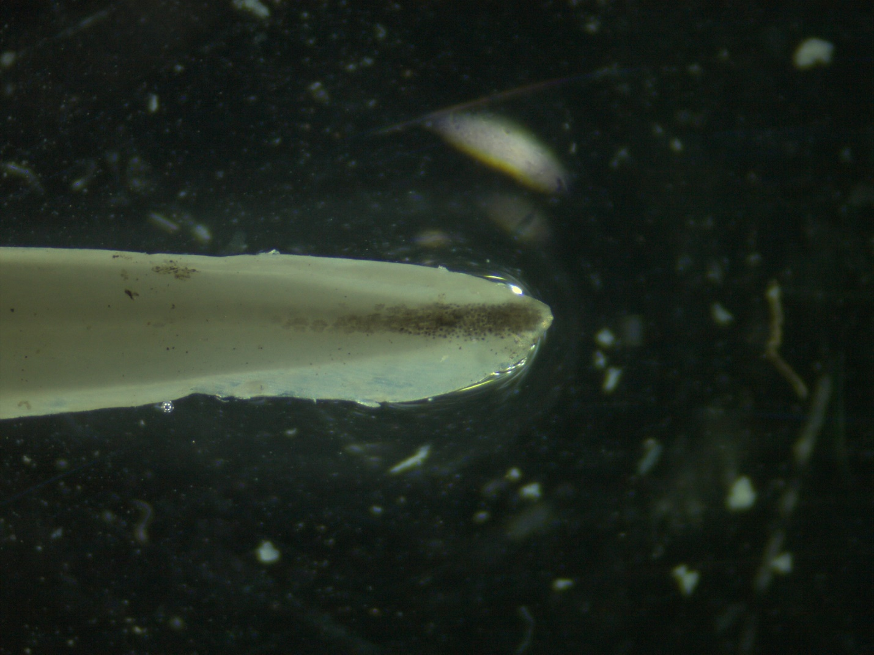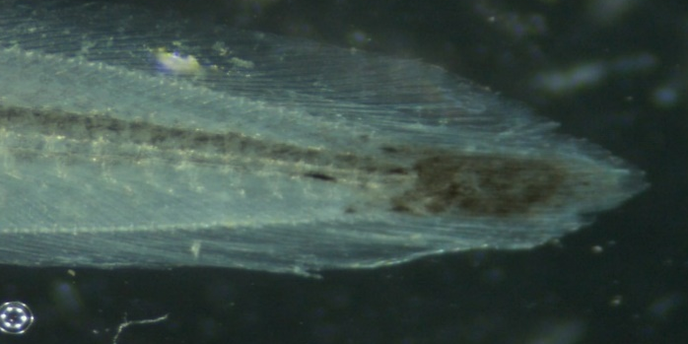
C

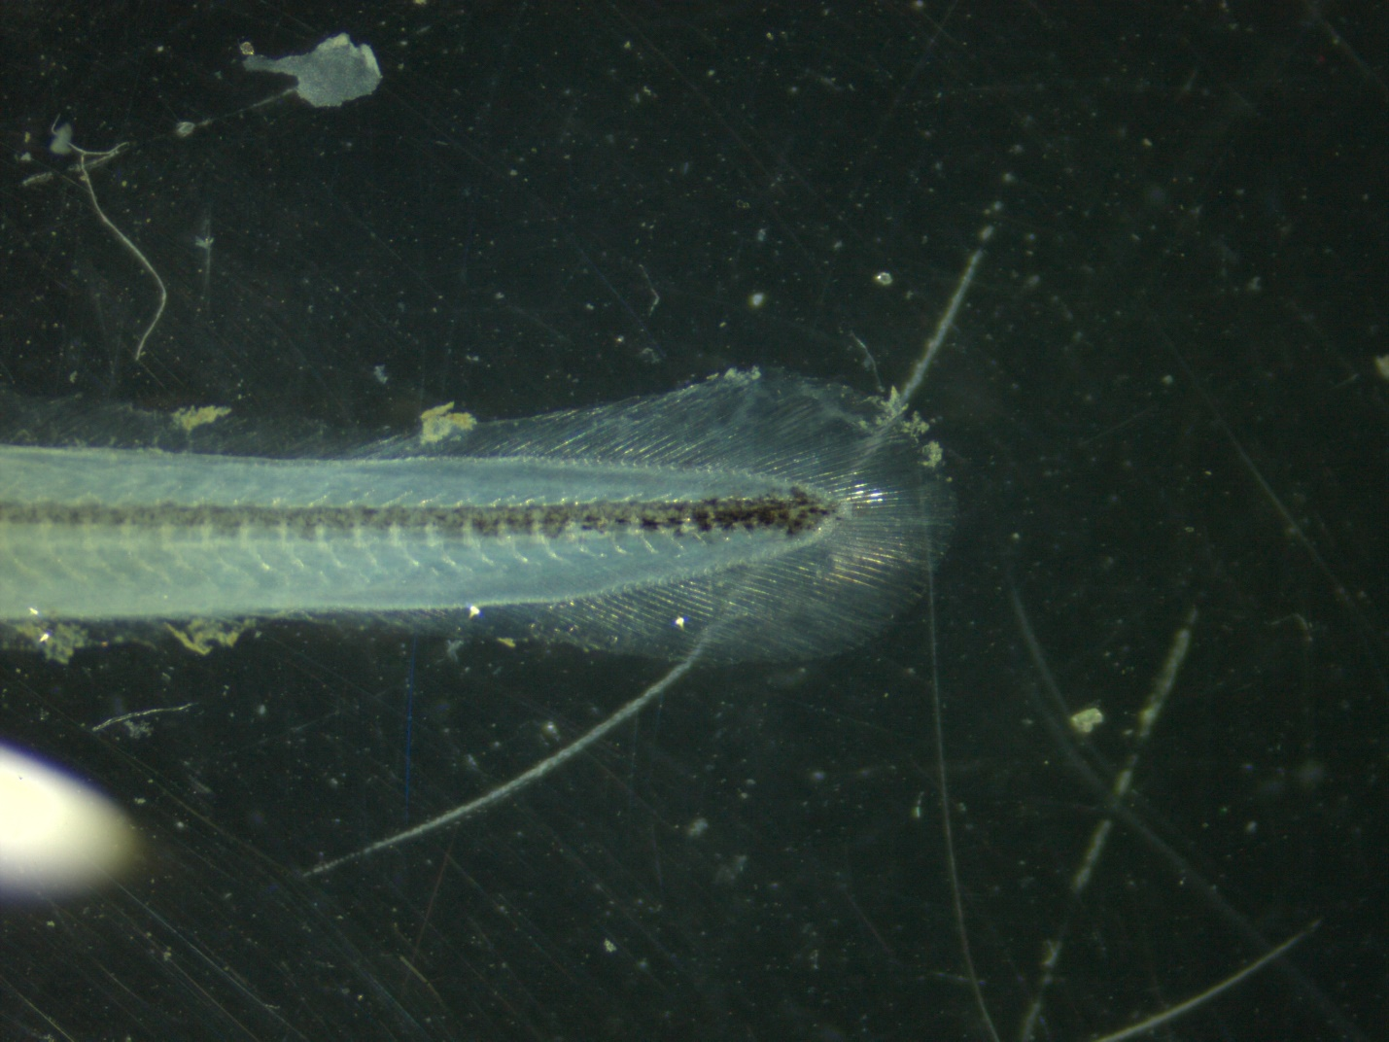
Figure 6: Caudal fin and tail pigmentation patterns of glass eels (A) A. bengalensis, (B) A. mossambica and (C) A. marmorata taken by Stemi 305, Carl Zeis microscope GmbH, Germany using ZEN imaging software at x 2 magnification respectively

Data analyses
Data were transferred from the field data sheets to Microsoft Excel sheet for analysis. All morphometric data were analysed using the descriptive statistics tool in Ms Excel to derive means and respective standard error of means (SEM). Taxonomic data were organized in tables, in which species were grouped into their respective families. Numbers of different life stages (i.e. glass eel and elver) of juvenile anguillids at various sampling stations summarized in tables to study spatial patterns, while respective numbers between sampling occasion over the study period provided insights on temporal trends.
Relative abundance for each species was calculated by dividing number of individual species by total number of caught species to asses species composition as well as temporal and spatial influence of juvenile anguillid eel species at different life stages (Equation 1);
$${RA}_{i}=\frac{N_{i}}{\sum{N_{i}}}×100$$
Where; RA= relative abundance and N = number of individuals of juvenile species.
The estuarine mean discharge was estimated according to Gordon et al. (2004) (Equation 2) and compared to the species of juvenile anguillid eels caught at each sampling site.
Q =∑ VA
Where; Q = Discharge (m3/s), V = Mean current velocity (m/s) and A = Cross-sectional area of the river channel (m2)
One-way Analysis of Variance (ANOVA) was used to determine the statistical significance of estuarine mean discharge on juvenile anguillid eel’s species caught. ANOVA was also used to test for significant differences in morphometrics (including total length, fin indices and ocular index) among juvenile anguillid eels in relation to species and life stages. Fin difference index (FDI) (Equation 3), according to Ege, (1939) was calculated as:
FDI =¼ 100 Z TL⁻¹
Where; FDI= distance between the verticals from beginning of the dorsal fin to the anal fin (Z) relative to the total length (TL).
Chi-square tests of association were used to determine association between the species and life stages of juvenile anguillids with various temporal factors; months, lunar and cycles. Significance was determined at p < 0.05 for all statistical tests.

CHAPTER FOUR

RESULTS

Species composition and relative abundance of fishes caught in the Sabaki Estuary
A total of 1236 fish belonging to 9 species and 7 families were sampled during the study period (Table 1). The species Glossogobius giuris (Hamilton, 1822) belonging to the estuarine family Gobiidae were the most abundant with a relative abundance of 72.6%, followed by Oreochromis spirulus spirulus (Gunther, 1894) 9.21% and Oreochromis mossambicus (Peters, 1852) (3.67%) belonging the family Cichlidae. The species Pisonodophis boro from the family Ophichthidae followed with a relative abundance of 3.51% followed by Bagrus docmak (Fabricius, 1775) from the Bagridae family 2.73%. Other species, Stenegobius kenyae (Smith, 1959), Planiliza alata (Steindachner, 1892) and Otolithes ruber (Bloch & Schneider, 1801), Barbus oxyrhynchus (Pfeffer, 1889) showed lower relative abundance < 2%.

Table 1: Species composition of fishes caught by glass eel fyke nets from the Sabaki Estuary during the study.
Family | Species | Local name | English Name | N | Relative Abundance (%)
Gobiidae | Glossogobius giuris | Jumburu | Tank goby | 927 |  | 72.36
 | Stenogobius kenyae | Jumburu | Africa river gobby | 25 |  | 1.95
Ophichthidae | Pisonodophis boro | Mkunga nyoka | Snake eel | 45 |  | 3.51
Sciaenidae | Otolithes ruber | Gufadi | Tiger tooth croaker | 14 |  | 1.09
Mugilidae | Planiliza alata | Mbinini | Diamond mullet | 24 |  | 1.87
Cichlidae | Oreochromis spirulus spirulus | Parapara | Sabaki tilapia | 118 |  | 9.21
 | Oreochromis mossambicus | Parapara | Mozambique tilapia | 47 |  | 3.67
Bagridae | Bagrus docmak | Fume | Sudan catfish | 35 |  | 2.73
Cyprinidae | Barbus oxyrhynchus | Karange | Pangani barb | 1 |  | 0.08
Total |  |  |  | 1276 |  | 100

Descriptive statistics on mean total length and weight measured for 9 species belonging to 7 families (Table 2) showed that the species Glossogobius giuris with the highest abundance (n=927), had a mean total length of 14.6 ± 3.11 cm and a mean weight of 23.3 ± 3.2 g. Whereas, the species Barbus oxyrhynchus (Pfeffer, 1889) had the smallest sample size with only 2 individuals, but had the highest mean total length of 124 ± 0.1 cm and a mean weight of 19 ± 0.3 g. Species Pisonodophis boro, (Hamilton, 1822) (n=45) had a relatively larger mean total length of 108.7 ± 24.9 cm and a mean weight of 71.4 ± 6.1 g. Other species Otolithes ruber, Planiliza alata, Bagrus docmak, and Oreochromis spirulus spirulus had mean measurements <35cm.
Table 2: Total length and weight of fishes caught in the Sabaki Estuary during the study
Species | N | Total Length (cm) | Weight (g)
Glossogobius giuris | 927 | 14.6 ± 3.11 | 23.3 ± 3.2
Pisonodophis boro | 45 | 108.7 ± 24.9 | 71.4 ± 6.1
Otolithes ruber | 14 | 20.2 ± 9.6 | 21.7 ± 4.8
Planiliza alata | 24 | 4.3 ± 0.17 | 2.7 ± 1.1
Bagrus docmak | 35 | 35.1 ± 8.8 | 79 ± 7.5
Oreochromis spirulus spirulus | 118 | 15.4 ± 3.2 | 26.6 ± 7.4
Oreochromis mossambicus | 23 | 16.3 ± 3.7 | 15.9 ± 3.1
Stenogobius kenyae | 25 | 69.9 ± 8.4 | 17.3 ± 6.3
Barbus oxyrhynchus | 2 | 124 ± 0.1 | 19 ± 0.3
Total | 1236

Species composition and life stages of juvenile anguillid eels caught in the Sabaki Estuary
A total of 76 juvenile anguillid eels belonging to 3 species and one family were caught and examined in the present study (Table 3). The juvenile anguillid eel life stage, found to be more abundant were glass eels (n = 66) followed by elvers (n = 10). The species A. bengalensis was the most abundant (n=50), among the three species caught with 65.79% (n=48) being glass eels and (n=2), 2.63% elvers. This was followed by A. mossambica with 22 individuals where, 18.42% (n=14), were glass eels and 10.53% (n=8) were elvers. Only 2.63% (n=4) A. marmorata were caught during this study.

Table 3: Species composition of juvenile anguillid eels caught in the Sabaki Estuary. Values in parenthesis indicate relative abundance (%) of both glass eel and elver juvenile anguillid eel life stages
 | Life stage
Species | Elver | Glass eel
A. bengalensis | 2 (20%) | 50 (76%)
A. marmorata | 0 (0%) | 2 (3.0%)
A. mossambica | 8 (80%) | 14 (21%)
Total | 10 (100%) | 66 (100%)

Morphometrics of juvenile anguillid eels
The species A. mossambica had the highest mean total length (Mean ± SE) 6.3 ± 1.8 cm, followed by A. bengalensis and A. marmorata with mean total length of 5.4 ± 0.5 cm and 5.2 ± 0.3 cm respectively (Table 4). Anguilla mossambica had the highest fin index i.e. DF to AF, with a mean length of (Mean ± SE) 24.9 ± 28.2 cm followed by A. marmorata with 12.5 ± 0.8 cm and A. bengalensis 12.3 ± 4.2cm. Results of FDI measurements on all 76 specimens were < 1% (Appendix 4). Eye morphometric measurements showed the species A. mossambica had the highest LED length 8.2 ± 7.3 cm and RED 8 ± 7.3 cm followed by A. marmorata 6.4 ± 0.9 cm, 6.3 ± 01 cm and trailed by A. bengalensis.

Table 4: Comparison of morphometric characteristics (TL= total length, DF to AF= dorsal fin to anal fin, LED= left eye diameter, RED= right eye diameter) (Mean ± SE) of juvenile anguillid species occurring in the Sabaki Estuary.
Species morphometrics | A. bengalensis | A. marmorata | A. mossambica
TL (cm) | 5.4 ± 0.5 | 5.2 ± 0.3 | 6.3 ± 1.8
DF to AF (cm) | 12.3 ± 4.2 | 12.5 ± 0.8 | 24.9 ± 28.2
LED (cm) | 6.3 ± 0.8 | 6.4 ± 0.9 | 8.2 ± 7.3
RED (cm) | 6 ± 0.9 | 6.3 ± 05 | 8 ± 7.3

Influence of temporal and spatial variability of juvenile anguillid eels caught in the Sabaki Estuary
Results of Chi-square tests of association showed that, throughout the sampling months, the highest number of juvenile anguillid eels were caught during the month of August 62% (n=41) (Table 5). The month of July and September showed similar counts of juvenile anguillid eels caught 3% (n=2), while the month of January showed no counts of juvenile anguillid eels. The species A. bengalensis was the most abundant among all three species, with the greatest catch occurring in the month of August 58% (n=29). Species, A. marmorata was the least abundant (n=2) caught in the month of August. Highest abundance of A. mossambica species was observed in the month of August 71% (n=10).
The month of August showed that glass eels of the species A. bengalensis 71% (n=29) and elvers of the species A. mossambica 20% (n=2) had the highest abundance of juvenile anguillid eels
caught in the present study. The species A. mossambica 50% (n=1) and A. bengalensis 50% (n = 1) showed a similar occurrence for both glass eels and elvers observed in the month of July and September. Anguilla marmorata had the lowest abundance for both glass eels and elvers, with only 9.8% (n=4) individuals caught in the month of August.

Table 5: Species monthly counts and relative abundance (%) of juvenile anguillid eels caught in the Sabaki Estuary
 | Month
Species | July | August | September | October | November |  | January | Total
A. bengalensis | 1 (2.0%) | 29 (58%) | 1 (2.0%) | 10 (20%) | 9 (18%) |  | 0 (0%) | 50 (100%)
A. marmorata | 0 (0%) | 2 (100%) | 0 (0%) | 0 (0%) | 0 (0%) |  | 0 (0%) | 2 (100%)
A. mossambica | 1 (7.1%) | 10 (71%) | 1 (7.1%) | 0 (0%) | 2 (14%) |  | 0 (0%) | 14 (100%)
Total | 2 (3.0%) | 41 (62%) | 2 (3.0%) | 10 (15%) | 11 (17%) |  | 0 (0%) | 66 (100%)

Table 6: Relative abundance (%) and monthly counts of life stages of juvenile anguillid eel species caught across sampling months
 | A. bengalensis |  |  | A. marmorata |  | A. mossambica |  | Total
Month | Glass eels |  | Elvers | Glass eels | Elvers | Glass eels | Elvers
July |  | 1 (50%) | 0 | 0 | 0 | 1 (50%) | 0 | 2 (100%)
August | 29 (71%) |  | 2 (20%) | 2 (4.9%) | 0 | 10 (24%) | 8 (80%) | 41 (100%)
September | 1 (50%) |  | 0 | 0 | 0 | 1 (50%) | 0 | 2 (100%)
October | 10 (100%) |  | 0 | 0 | 0 | 0 | 0 | 10 (100%)
November | 9 (82%) |  | 0 | 0 | 0 | 2 (18%) | 0 | 11 (100%)
January | 0 |  | 0 | 0 | 0 | 0 | 0 | 0
Total | 50 (76%) |  | 2 (20%) | 2 (3.0%) | 0 | 14 (21%) | 8 (80%) | 66 (100%)

Species composition of juvenile anguillid eels caught across different lunar phases showed that, A. bengalensis 64% (n=18) and A. mossambica were more abundant during the waning gibbous lunar phase. Anguilla marmorata showed similar abundance (n=1) during the waning gibbous and waxing crescent lunar phases. The statistical significance of the association between the lunar phase and the catch rate showed no significant difference between the two variables (P<0.05). Results of Shannon weaver diversity index showed that the last quarter phase of the moon showed a higher diversity index of 1.9 followed by the full moon 1.43, then waning gibbous 1.3, and first quarter 1.04. The waxing crescent had the lowest 0.79 diversity index.
Association between counts of the life stages of juvenile anguillid eel species, caught across different lunar phases showed that most glass eels and elvers occurred during the waning gibbous (n=22) and (n=6) respectively (Table 8). Similarly, glass eels of A. bengalensis species, 73% (n=16) were abundant during the waning gibbous lunar phase while glass eels of A. mossambica (n=4) were more abundant during the first quarter and waxing crescent lunar phase. The highest number of anguillid elvers were caught during the last quarter 67% (n=4) phase of the moon.
Table 7: Relative abundance (%) of juvenile anguillid eel species caught in different lunar phases in the Sabaki Estuary
Lunar phase | A. bengalensis |  | A. marmorata | A. mossambica | Total
First quarter |  | 10 (71%) | 0 | 4 (29%) | 14 (100%)
Full moon |  | 10 (100%) | 0 | 0 | 10 (100%)
Last Quarter |  | 8 (67%) | 0 | 4 (33%) | 12 (100%)
Waning gibbous |  | 18 (64%) | 1 (3.6%) | 9 (32%) | 28 (100%)
Waxing crescent |  | 6 (50%) | 1 (8.3%) | 5 (42%) | 12 (100%)
Total |  | 52 (68%) | 2 (2.6%) | 22 (29%) | 76 (100%)

Table 8: Relative abundance (%) and lunar counts of juvenile anguillid eels caught during the study
 | A. bengalensis |  | A. marmorata |  | A. mossambica |  | Total
Lunar phase | Glass eels | Elvers | Glass eels | Elvers | Glass eels | Elvers | Glass eels | Elvers
First Quarter | 8 (57%) | 0 | 2 (14%) | 0 | 4 (29%) | 0 | 14 (100%) | 0
Full moon | 10 (100%) | 0 | 0 | 0 | 0 | 0 | 10 (100%) | 0
Last Quarter | 8 (89%) | 0 | 0 | 0 | 1 (11%) | 3 (100%) | 9 (100%) | 3 (100%)
Waning Gibbous | 16 (73%) | 2 (33%) | 1 (4.5%) | 0 | 5 (23%) | 4 (67%) | 22 (100%) | 6 (100%)
Waxing Crescent | 6 (55%) | 0 (0%) | 1 (9.1%) | 0 | 4 (36%) | 1 (100%) | 11 (100%) | 1 (100%)
Total | 48 (73%) | 2 (20%) | 4 (6.1%) | 0 | 14 (21%) | 8 (80%) | 66 (100%) | 10 (100%)

Sampling site SBE1 showed higher abundance (n=24), followed by SBE4 (n=23), SBE3 (n=18) and SBE2 (n=11) of juvenile anguillid eels caught in the Sabaki Estuary (Table 9). Species A. bengalensis, were more abundant in sampling site SBE4 n=18 (78%) while species A. mossambica 9 (38%) were abundant at sampling site SBE1. Anguilla marmorata were both abundant in sampling site SBE1 2 (8.3%).
Table 10: Relative abundance (%) and counts of juvenile anguillid eel species caught from sampling site SBE1-SBE4 in Sabaki Estuary
Effort | A. bengalensis | A. marmorata | A. mossambica | Total
SBE 1 | 13 (54%) | 2 (8.3%) | 9 (38%) | 24 (100%)
SBE 2 | 16 (89%) | 0 | 2 (11%) | 18 (100%)
SBE 3 | 5 (45%) | 0 | 6 (55%) | 11 (100%)
SBE 4 | 18 (78%) | 0 | 5 (22%) | 23 (100%)
Total | 52 (68%) | 2 (2.6%) | 22 (29%) | 76 (100%)
The largest mean size (Mean ± SD) of species A. mossambica glass eels were caught at sampling site SBE4 (5.57±0.87 cm) followed by, SBE3 (5.43±0.23 cm), while the smallest mean size was caught in site SBE2 (5.25±0.21 cm) and SBE1 (5.25±0.21 cm) respectively. The largest mean size (Mean ± SD) of A. bengalensis species were caught at sampling site SBE3 (5.4±0.33 cm) and SBE4 (5.4±0.2 cm) followed by, SBE2 (5.37±0.35 cm) while sampling site SBE1 (5.3±0.45 cm) had the smallest mean size. Glass eels of A. marmorata species only caught at sampling site SBE4 measured 5.2±0.28 cm. Elvers of A. mossambica in sampling site SBE1, SBE3 and SBE4 had mean total lengths (Mean ± SD) of 5.43±0.15 cm, 8.33±1.54 cm and 10.4±0.85 cm, respectively. Elvers of A. bengalensis present in sampling site SBE2, and SBE3 measured 7.5±0.1 cm and 7.3±0.1 respectively.
Table 11: Mean total lengths (Mean ± SD) of juvenile anguillid eel species caught across four sampling sites: SBE1, SBE2, SBE3, and SBE4 in Sabaki Estuary
Species | SBE1 |  | SBE2 | SBE3 |  | SBE4
Glass eels
A. mossambica | 5.25±0.21 |  | 5.28±0.23 | 5.43±0.23 |  | 5.57±0.87
A. bengalensis | 5.3±0.45 |  | 5.37±0.35 | 5.4±0.33 |  | 5.4±0.2
A. marmorata | _ |  | _ | _ |  | 5.2±0.28
Elvers
A. mossambica | 5.43±0.15 |  | _ | 8.33±1.54 |  | 10.4±0.85
A. bengalensis | _ |  | 7.5±0.1 | 7.3±0.1 |  | _

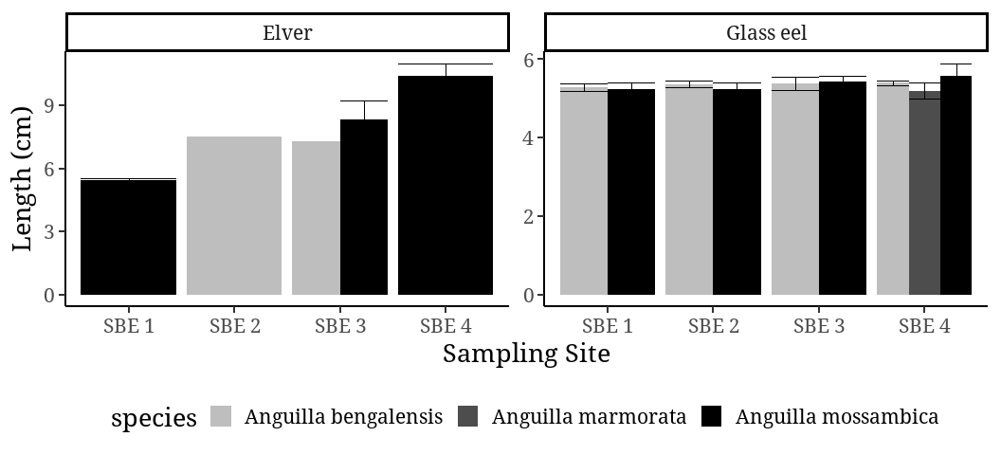
Figure 7: Total length (TL) measurements of juvenile anguillid eel species caught from sampling site SBE1, SBE2, SBE3 and SBE4
Results of one-way analysis of variance (ANOVA) showed spatial differences in discharge flow rates among all four sampling sites (Table 12). Sampling site SBE2 and SBE3 had relatively higher discharge flow rate at 11 m³/s and 10 m³/s respectively. Sampling site SBE4 showed lower discharge flow rate of 1 m³/s while no discharge was reported at site SBE1.
Table 12: Variations of discharge flow rates (m³/s) across four sampling sites: SBE1, SBE2, SBE3, and SBE4 in Sabaki Estuary
Sampling Site | SBE1 | SBE2 | SBE3 | SBE4
Discharge (m3/s) | 0 | 11 | 10 | 1

Species composition varied across different discharge rates. A. bengalensis and A. mossambica occurred at similar discharge flow rates of 8 m³/s, while A. marmorata showed to occur when the estuarine discharge rate was lower at 1 m³/s. One way analysis of variance (ANOVA) showed no significant difference (p-value = 0.1).
Table 13: Species composition of juvenile anguillid eels caught at varying discharge flow rates (m³/s) in the Sabaki Estuary
Species | A. bengalensis | A. marmorata | A. mossambica
Discharge (m3/s) | 8 | 1 | 8

CHAPTER FIVE

DISCUSSION
The present study is the first to investigate the presence of juvenile anguillid eels within the Sabaki Estuary. While there are many different species of eels, those belonging to the genus Anguilla are the sole representatives of the Anguillidae family, which is one of the numerous families comprising the order Anguilliformes (Arai et al., 2002; Arai., 2015; Miller and Mc Cleave., 2018). In the present study, the juvenile anguillid life stages present within the Sabaki Estuary were the glass eel and elver life stage. Glass eels (n=66) were more abundant, while a very limited number of elvers (n=10) were captured. In contrast to earlier records, only elvers have been reported in Kenya rivers (Frost, 1995; Van Someren and Whitehead, 1959). In April 1958, an investigation of the draft tubes in the turbines of the Tana Hydro-electric Power Station, located on the Tana River by Van Someren and Whitehead, 1959, resulted in the discovery of eighteen juvenile anguillid eels. These eels had been trapped in the syphon-priming chamber of the dam, designed to serve as an effective mechanism for capturing young eels. The eighteen juvenile eels reported were mottled, this colouration highlights the specimens observed were indeed not glass eels.
The effectiveness of modern sampling methods such as glass eel fyke nets, attributes to the difference in abundance of caught juvenile anguillid eels caught in the present as compared to earlier records. Glass eel fyke nets are designed with a funnel shape and a small mesh size that permits glass eels to swim into the entrance but impedes their ability to exit, ultimately ensnaring them within the meshed chamber. Thereby, given how the relatively smaller size of glass eels are in comparison to elvers, the deployment of glass eel fyke nets in the present study increased the likelihood of capturing this life stage, as opposed to the draft turbine tubes implemented by Van Someren and Whitehead, (1959).
One of the key influences of upstream migration of juvenile anguillid eels is predicted largely by seasonal rainfall and lunar phase eels (Chisnall et al., 2002). In Kenya, there are two rainy seasons in the coastal region (ASCLME, 2012) The long rainy season occurs between the months of March and May while the short rainy season is experienced between the months of October and November (ASCLME, 2012). In the present study, abundance of juvenile anguillids was observed to be higher in the month of August. In contrast, the eighteen elvers documented to be caught in the turbines of the Tana Hydro-electric Power Station, in Tana River by Van Someren and Whitehead, (1959), were captured in the month of April during the short rainy seasons, however subsequent visits during the season did not any positive results. The report suggested that an increase in young stages could be anticipated during the long rainy season, between March and May when the region experiences prolonged rain floods.
Rainy seasons offer advantageous conditions for the recruitment process, due to the presence of freshwater runoff (Robinett et al., 2003; Meynecke et al., 2006). Arguably, a study on fish community structure and distribution in the Sabaki river, Kimwaka, (2004) highlighted that during the wet season, the sea became rough leading to an increase in river discharge, bringing with it a significant amount of silt-laden runoff from the surrounding upland areas. This resulted to fish becoming dispersed over a much larger area, making it difficult for their capture. Thereby, it can be inferred that the juvenile anguillid eels possess a remarkable level of adaptability, being able to persevere through the challenging conditions present in estuaries during the wet seasons as they embark on their inshore and upstream migration.
However, while Arai et al. (2016) reported that recruitment of tropical glass eels, do occur all year round this was not observed in the Sabaki Estuary. In the present study, no occurrence of juvenile anguillid eels observed to occur in the month of January. Similarly, the single elver caught in the Sabaki River was documented to have been captured in the month of November during the short rainy season. In the Ré Union Island rivers, recruitment of tropical glass eels is documented to only occur 5 months in a year, recruiting between the months of November and March (Robinet et al., 2003). In the Eastern Cape of South Africa recruitment of smaller-sized elvers into freshwater habitats has a recognized pattern with high abundance of elvers observed to be greater during summer and autumn seasons compared to winter and spring (Wasserman et al., 2012).
Anguilla bengalensis was consistently the most abundant species of juvenile anguillid eels that were caught in the Sabaki Estuary, followed by A. mossambica and, to a much lesser extent, A. marmorata. This corroborates with the preliminary study on the species diversity of adult eels in Kenyan rivers reported by Frost, (1995) whereby the species A. bengalensis were found in greater numbers in altitudes above of 3,000 ft, while A. mossambica was reported as not common and A. bicolor as rarely found, as it seemed to have limited distribution in the lower areas of rivers. Additionally, the 18 Tana River elvers documented by Van Someren and Whitehead, (1959) were identified as A. bengalensis the only documentation of a juvenile anguillid eel within the Sabaki River was documented to have been captured 20 miles from the sea at an altitude 100 ft in Jilore (Van Someren and Whitehead, 1959). The elver was identified to be of A. mossambica species.
While A. marmorata is considered the most widely distributed species, occurring in the southern cape of South Africa, all the way to the east African coast (Hanzen et al., 2020), as well as the only documented species in the Sabaki River according to earlier records (Van Someren and Whitehead, 1959), it was however the least dominant species within the Sabaki Estuary. This can be explained by. geographic ranges, temperature preferences, and behavioural patterns of adult anguillid eels. For instance, spawning grounds of adult anguillid eels and transportation of their larvae by different currents to their destination better explains the abundance of specific juvenile anguillid species (Fukuda et al., 2013).
The identification of freshwater anguillid eels commonly employs the use of pigmentation patterns on the caudal fin and the ratio of fin morphometrics to total length as a significant criterion. The caudal fins of all 76 individuals sampled were observed to be rounded and pigmented, allowing for clear species identification. Pigmentation patterns of A. mossambica juveniles appeared as a dark blotch just at the tip of the caudal keel, however, not extending towards the end of the caudal fin. Anguilla marmorata pigmentation begun from the tip of the caudal keel and extended inwards towards the body merging together with the medio-lateral line while A. bengalensis pigmentation begun from the tip of the caudal fin and extended inwards towards the body merging together with the medio-lateral line.
While Revelliac et al. (2009) method proved to be a successful protocol for the identification of morphological characteristics in the present study, accurate identification of tropical anguillid eels needs to be validated by molecular genetics after morphological observation (Hebert et al., 2003; Raudah et al., 2015; Trivedi et al., 2016; Peninal et al., 2017; Wang et al., 2018). For instance, in sub samples of 205 glass eel sub species morphologically identified as A. mossambica by Revelliac et al. (2009), 3 were validated through molecular analysis as A. marmorata. A study on the identification of tropical anguillid eels in Cagayan River, Philippines by Hilario et al. (2022) through sequencing of the mitochondrial cytochrome b gene showed that morphological analysis of elvers was not entirely reliable as it resulted in the misidentification of certain elvers of A. marmorata species as A. luzonensis, and vice versa.
However, the feasibility of integrating both morphological and molecular analyses in the current study was not possible. Thereby, the application of alternative morphological techniques such as the use of eye and fin indices, revealed certain distinctions among the identified species. In specimens studied, eye morphometrics correlated with total length. Specimens of A. mossambica species were the largest with a relatively higher ocular diameter and TL >. Eye index of 80 ± 73mm with a TL range of 6.29 ± 1.81 cm belonged to A. mossambica species. This was much comparable to the species of A. marmorata which had an average eye index rage of 63 ± 5mm with a TL range of 5.20 ± 0.28cm observed to be much smaller in size. While eye morphometrics have only been previously used to asses sexual maturation in silvering anguillid eels (Beullens et al., 1997: Francis, 2006; Okamura et al., 2007; Hagihara et al., 2012) as well as developmental stages of gonads in adult anguillid eels (Beullens et al., 1997), none has been linked to the identification of juvenile anguillid eels. Hence, these results highlighted a significant morphometric which could aid further identification guide in the identification of juvenile anguillid eels.
Similar to eye morphometrics, fin indices showed distinctions between species of juvenile anguillid eels sampled. Fin morphometrics showed that species A. mossambica were much larger followed by A. marmorata and A. bengalensis species. However, results of FDI measurements calculated as the length between dorsal and dorsal fin relative to the total length (TL), for all for all specimens were < 1% and did not conform to Ege, (193) taxonomic key for all three species of juvenile anguillid eels caught. Therefore, while the key has been successful in identifying adult anguillid eels (Watanabe et al., 2004; Raudah et al., 2015), it is however limited when it comes to the identification of their juveniles.
Spatial distribution of eels was observed in all four sampling points. Abundance was significantly higher on both sampling stations i.e. (1) SB4 furthest from the mouth and (2) SBE1 most proximate to the mouth of the estuary, whereas abundance was lower in the mid sampling site SBE2 and SBE3 proximate to the Sabaki bridge. Additionally, upstream migration of juvenile anguillid eels into freshwater showed a gradual increase in size from sampling site SBE1 most proximate to the estuary mouth, to site SBE4 furthest to from the mouth. For instance, glass eels of A. bengalensis slightly increased in size from site SBE1 5.3±0.45 cm too site SBE4 5.4±0.2 cm. Similarly, glass eels of A. mossambica showed a gradual increase in size as the species moved from site SBE1 5.25±0.21 cm to SBE4 5.57±0.87 cm. Elvers also depicted a similar trend increasing in size from 5.43±0.15 cm at site SBE1 to 10.4±0.85 cm at sampling site SBE4 respectively for A. mossambica species. According to Feunteunet et al. (2003) upstream migration of juvenile anguillid eels into freshwaters, decrease in abundance but increase in size and age when moving from downstream to upstream.
The spatial variation in both abundance and size of juvenile anguillid eels during inshore and upstream migration can be attributed to several factors such as estuarine depth, predation and habitat preference (Jellyman et al., 1977; Glova., 1999; Pease, 1999; Sugeha et al., 2001; Gomez, 2005; Harrison et al., 2014; Miyake et al., 2018). A study by Laffaille et al. (2007) showed that glass eels migrate into more deep waters as they got older in search for food and refugia, hence their increase in size in sites furthest to the mouth. This phenomenon can be explained by the influence of lunar cycles on light intensity, which causes glass eels to migrate deeper in the water column hence reduced catchability (Gomez, 2005; Harrison et al., 2014). The greatest number of juvenile anguillid eels were caught during the waning gibbous lunar phase, suggesting that the lunar phase has a strong effect on inshore migration mechanism of juvenile anguillid eels in the Sabaki Estuary.
A similar pattern was observed by Gollub (cited in Sugeha et al., 2001) in temperate glass eels whereby, the highest abundance of A. Anguilla elvers were recorded to occur during the waning moon and new moon phase. However, the present study differs from, Sugeha et al. (2001) whereby, fewer glass eels of the tropical species A. celebesensis, A. marmorata and A. bicolor were reported to be collected during the full moon whereas, a higher number of glass eels were collected during the new moon phase as compared to the waxing and waning moons. Thereby, it can be debated that while moonlight intensity does play a role in influencing both inshore and upstream migration influence may differ according to temperate and tropical juvenile anguillid eel species. Additionally, Harrison et al. (2014) found that turbid conditions within estuaries impact the recruitment of glass eels during both inshore and upstream migration. According to the authors turbidity limit light penetration hence, limiting the impact of lunar cycles on the migratory behaviour of juvenile glass eels.
While predation is generally considered one of the main factors which affects the recruitment of glass eels, their preference for habitat is based on the desire to use the most effective shelter so as to minimize the probability of predation (Glen and Dickman., 2014; Miyake et al., 2018). However, knowledge on tropical juvenile anguillid eels is limited, but has been reported for some temperate species. For instance, elvers have been reported to be predated on by larger anguillids of the American and New Zealand long-finned eel (Jellyman et al., 1977; Cowan and Shaw, 2002; Almany and Webster, 2006; Miyake et al., 2018). Miyake et al. (2018) reported species catfish and blackfin sea bass to be important predators of glass eels of A. japonica the Japanese eel. Other predators include; trout, birds (cormorants, ducks, kingfishers) and water rats (Miyake et al. 2018). Juvenile anguillid eels are less prone to predation in heterogeneous habitats such as rock and sea grass contain small interstitial spaces that can be used for shelter compared to homogenous habitats such as sand and mud (Glova, 1999; Silberschneider et al., 2004).
The Sabaki Estuary displays varying habitat characteristics, from the open seawater near the mouth to upstream regions (McClanahan and Arthur, 2001; Kitheka et al., 2013; Kitheka et al., 2015). However, the down-estuary region adjacent the Indian Ocean proximate to sampling site SBE1 is characterized by a small mangrove forest habitat, which has been degraded due to smothering of breathing roots by the huge quantity of deposited terrigenous sediments (Robertson and Duke, 1987; McClanahan and Arthur, 2001; Kitheka et al., 2015). Thereby it is sufficient to assume that as a result as a result, the habitat around sampling site SBE1 is not preferable as a feeding ground preference of juvenile anguillid eels and would rather migrate to upper estuarine region for feeding and refugia, which is essential for their growth and transition to the next stage of their life cycle (Silberschneider et al., 2001; Harrison et al., 2014). A phenomenon which was not found in the lower estuarine sampling region as compared to the upper estuarine sampling region
A research study carried out by Glova, (1999), whereby when presented with different habitats, juvenile anguillid eels preferred complex natural habitats with substrates such as those with watercress and to a lesser degree, woody debris as a means of avoiding predation. Additionally, a study done by Silberschneider et al., (2001) in an experiment using glass eel collectors designed to mimic the complexity of Zostera seagrass mimicking complex natural habitats showed that when the collectors were disturbed, glass eels would burrow deeper into the protective tufts, replicating the protective behaviour that they display in their natural habitat.
Species composition showed a distinct pattern whereby, A. bengalensis and A. mossambica were more abundant during periods of elevated water flows, characterized by discharge rates of 8 m³/s. In contrast, A. marmorata were more abundant during conditions of lower discharge flow, of 1 m³/s. This correlation is more evident by observing that A. bengalensis and A. mossambica were similarly more abundant at sampling sites SBE1 and SBE4. Spatial differences in river discharge also showed higher discharge flow rates observed at sampling site SBE2 and SBE3, 11 m3/s and 10 m3/s respectively. Lower discharge flow was observed at the mot downstream and upstream sampling sites SBE1 and SBE4 at 0 m3/s and 1 m3/s respectively. These results are consistent with the river continuum concept (RCC) which indicates that discharge is usually lowest downstream but increases midstream and upstream (Tornwall et al., 2015; Larsen et al., 2019; Doretto et al., 2020). Discharge was higher at sampling sites located mid estuarine region. Similarly, higher abundance of juvenile anguillid eels were observed in sampling site SBE1 and SBE4 at (n=24) and (n=23) respectively. Accordingly, this suggests that juvenile anguillid eels tend to inhabit areas with much slower moving water.
The relationship between river flow on inshore and upstream migration of juvenile anguillid eels can be attributed to predation (Bru et al., 2009; Glen and Dickman., 2014; Miyake et al., 2018), habitat preference (Glova, 1999; Silberschneider et al., 2001; Harrison et al., 2014) and olfactory cues (Tesch, 2003; Edeline et al., 2009). During periods of high river flow, juvenile anguillid eels tend to settle near the lower banks of the estuary to avoid being carried back downstream (Harrison et al., 2014). This however makes them more susceptible to exploitation and predation (Bru et al., 2009; Harrison et al., 2014). A similar orientation is observed whereby glass eels burry themselves into the substratum so as to conserve energy for upstream migration by maintaining a stationary position (Trancart et al., 2012). External cues such as odour associated with river flow, have also been documented to regulate the timing and duration of glass eels (Harrison et al., 2014). Anguillid eels have a very highly developed olfactory system, capable of detecting odour at extremely concentrations (Martin, 1995; Harrison et al., 2014). During selective tidal stream transport, the smell of freshwater triggers increases swimming activity, facilitating orientation towards inland waters (Tesch, 2003; Edeline et al., 2009; Harrison et al., 2014).

CHAPTER SIX

CONCLUSION AND RECOMMENDATIONS
This study is the first to document the occurrence, taxonomic composition and ecological aspects of juvenile anguillid eels in Sabaki Estuary. The results of this study have significance in terms of enhancing our understanding of the biology, taxonomy and ecology of juvenile anguillid eels. It would be beneficial to conduct a subsequent study that examines the correlation between external morphological identification and genetic identification in order to genetically discern the specific species recruiting within the Sabaki Estuary. The present study needs to encompass accurate genetic identification and characterization of individual juvenile anguillids, which is essential for understanding their distribution, migration patterns and population dynamics monitored over a relatively longer period of time. Thereby there is a need for further taxonomic studies in this field. Furthermore, it is my aspiration that this study will serve as a foundation for the implementation of subsequent conservation and management strategies pertaining to these species in the future.

REFERENCE
Abuodha JOZ. 1998. Geology, geomorphology, oceanography and meteorology of Malindi Bay. In Hoorweg ed Dunes, groundwater, mangroves and birdlife in Coastal Kenya. (pp. 17-39). Coastal Ecology Series No.4. Nairobi: ACT.
Adam G, Feunteun E, Prouzet P, Rigaud C. 2008. The European eel: indicators of abundance and colonization. Quae; 2008 Nov 18.
Almany GR, Webster MS. The predation gauntlet: early post-settlement mortality in reef fishes. Coral reefs 25:19-22.
Arai T and Abdul Kadir SR. 2017. Opportunistic spawning of tropical anguillid eels Anguilla bicolor bicolor and A. bengalensis bengalensis. Scientific reports 30;7(1):1-7.
Arai T and Chino N. 2012. Diverse migration strategy between freshwater and seawater habitats in the freshwater eel genus Anguilla. Journal of Fish Biology 81(2):442-55.
Arai T and Wong L. 2016. Validation of the occurrence of the tropical eels, Anguilla bengalensis bengalensis and A. bicolor bicolor at Langkawi Island in Peninsular Malaysia, Malaysia. Tropical Ecology 57: 23-3.
Arai T, Abdul Kadir SR and Chino N. 2016. Year-round spawning by a tropical catadromous eel Anguilla bicolor bicolor. Marine Biology. 2016 Feb;163(2):1-7.
Arai T, Aoyama J, Limbong D and Tsukamoto K. 1999. Species composition and inshore migration of the tropical eels Anguilla spp. recruiting into the estuary of the Poigar River, Sulawesi Island. Marine Ecology Progress Series, 188, pp.299-303.
Arai T, Chai IJ, Iizuka Y and Chang CW. 2020. Habitat segregation and migration in tropical anguillid eels, Anguilla bengalensis bengalensis and A. bicolor bicolor. Scientific Reports 10(1):1-3. Righton D, Piper A, Aarestrup K, Amilhat E, Belpaire C, Casselman J, Castonguay M, Díaz E, Dörner H, Faliex E and Feunteun E. 2021. Important questions to progress science and sustainable management of anguillid eels. Fish and Fisheries 4:762-88.
Arai T, Marui M, Otake T and Tsukamoto K. 2002. Inshore migration of a tropical eel, Anguilla marmorata, from Taiwanese and Japanese coasts. Fisheries Science, 68; 152–157.
Arai T, Sugeha HY, Limbong D, Tsukamoto K. 2020. Rhythmic activity of inshore migration of tropical freshwater glass eels of the genus Anguilla. Environmental Biology of Fishes 103(11):1295-308.
Arai T. 2015. Biology and ecology of anguillid eels. CRC Press Taylor & Francis Group 13: 978-1-4822-5516-4.
Arribas C, Ferna´ndez-Delgado C, Olivia-Paterna FJ, Drake P. 2012. Oceanic and local environmental conditions as forcing mechanisms of the glass eel recruitment to the southernmost European estuary. Estuar Coast Shelf S 107:45–5.
ASCLME 2012. National Marine Ecosystem Diagnostic Analysis. Kenya. Contribution to the Agulhas and Somali Current Large Marine Ecosystems Project (supported by UNDP with GEF grant financing).
Bardonnet A, Bolliet V, Belon V. 2005. Recruitment abundance estimation: role of glass eel (Anguilla anguilla L.) response to light. Journal of Experimental Marine Biology and Ecology 13;321(2):181-90.
Bardonnet A, Dasse S, Parade M, Heland M. 2003. Study of glass-eel’s movements in a flume in relation to nycthemeral changes. Bulletin Français de la Pêche et de la Pisciculture (France). 2003.
Beullens K, Eding EH, Ollevier F, Komen J, Richter CJ. 1997. Sex differentiation, changes in length, weight and eye size before and after metamorphosis of European eel (Anguilla anguilla L.) maintained in captivity. Aquaculture 153(1-2):151-62.
Beullens K, Eding EH, Ollevier F, Komen J, Richter CJ. 1997. Sex differentiation, changes in length, weight and eye size before and after metamorphosis of European eel (Anguilla anguilla L.) maintained in captivity. Aquaculture 153(1-2):151-62.
Briand C. 2009. Population and migration dynamics of glass eels in the Vilaine estuary. Doctoral dissertation, Rennes, Agrocampus Ouest.
Bru N, Prouzet P, Lejeune M. 2009. Daily and seasonal estimates of the recruitment and biomass of glass eels runs (Anguilla anguilla) and exploitation rates in the Adour open estuary (Southwestern France). Aquatic living resources 22(4):509-23.
Bureau Du Colombier S, Bolliet V, Lambert P, Bardonnet A. 2007. Energy and migratory behaviour in glass eels (Anguilla Anguilla). Physiology & behavior 92:684–690.
Chino N and Arai T. 2010. Habitat use and habitat transitions in the tropical eel, Anguilla bicolor bicolor. Environmental biology of fishes 89:571-8.
Chisnall BL, Jellyman DJ, Bonnett ML, Sykes JR. 2002. Spatial and temporal variability in length of glass eels (Anguilla spp.) in New Zealand. New Zealand Journal of Marine and Freshwater Research 36(1):89-104.
Cresci A, Durif CM, Paris CB, Shema SD, Skiftesvik AB and Browman HI. 2019. Glass eels (Anguilla anguilla) imprint the magnetic direction of tidal currents from their juvenile estuaries. Communications biology 2(1):1-8
Cresci A. 2020. A comprehensive hypothesis on the migration of European glass eels (Anguilla anguilla). Biological Reviews.
Creutzberg F. 1961 On the orientation of migrating elvers (Anguilla vulgaris, Turt.) in a tidal area. Netherlands Journal of Sea Research 1(3):257–338.
Criales MM, Robblee MB, Browder JA, Cardenas H and Jackson TL. 2011. Field observations on selective tidal-stream transport for postlarval and juvenile pink shrimp in Florida Bay. Journal of Crustacean Biology 31(1):26-33.
Crivelli AJ, Auphan N, Chauvelon P, Sandoz A, Menella JY, Poizat G. 2008. Glass eel recruitment, Anguilla anguilla (L.), in a Mediterranean lagoon assessed by a glass eel trap: factors explaining the catches. InFish and Diadromy in Europe (ecology, management, conservation) Proceedings of the symposium held 29 March–1 April 2005, Bordeaux, France 2008 (pp. 79-86). Springer Netherlands.
Cuvin-Aralar ML, Aya F, Romana-Eguia MR, Logronio DJ. 2019. Nursery culture of tropical anguillid eels in the Philippines. Aquaculture Department, Southeast Asian Fisheries Development Center; 2019.
Dekker W, Casselman JM, Cairns DK, Tsukamoto K, Jellyman D and Lickers H. 2003. Worldwide decline of eel resources necessitates immediate action. Quebec Declaration of Concern. Fisheries 28, 28–30.
Dekker W. 2002. Monitoring of glass eel recruitment. Netherlands Institute of Fisheries Research, report C007/02-WD, 256 pp.
Doretto A, Piano E and Larson CE. 2020. The River Continuum Concept: lessons from the past and perspectives for the future. Canadian Journal of Fisheries and Aquatic Sciences 77(11):1853-64.
Dou S-Z and Tsukamoto K. 2003. Observations on the nocturnal activity and feeding behaviour of Anguilla japonica glass eels under laboratory conditions. Environmental Biology of Fishes 67(4): 389–395.
Dzoga, M., Simatele, D., & Munga, C. 2018. Assessment of ecological vulnerability to climate variability on coastal fishing communities: A study of Ungwana Bay and Lower Tana Estuary, Kenya. Ocean & Coastal Management, 163: 437–444.
Edeline E, Bardonnet A, Bolliet V, Dufour S, Elie P. 2005. Endocrine control of Anguilla anguilla glass eel dispersal: effect of thyroid hormones on locomotor activity and rheotactic behavior. Hormones and behavior 48(1):53-63.
Edeline E, Dufour S, Elie P. 2009. Proximate and ultimate control of eel continental dispersal. Inspawning migration of the European eel: reproduction index, a useful tool for conservation management. pp. 433-461 Dordrecht: Springer Netherlands.
Edeline E, Lambert P, Rigaud C, Elie P. 2006. Effects of body condition and water temperature on Anguilla anguilla glass eel migratory behavior. Journal of Experimental Marine Biology and Ecology331(2):217-25.
Ege V. 1939. A revision of the genus Anguilla Shaw: a systematic, phylogenetic and geographical study. Dana Rep 16: 1–256.
Elliott, M., Whitfield, A.K., Potter, I.C., Blaber, S.J., Cyrus, D.P., Nordlie, F.G. and Harrison, T.D. (2007). The guild approach to categorizing estuarine fish assemblages: a global review. Fish and fisheries,8(3), 241-268.
Engelbrecht J, Bills R, Marshall B and Cambray J. 2010. Anguilla bengalensis ssp. labiata. The IUCN Red List of Threatened Species 2010: e.T183182A8070107.
Francis, M.P. (2006). Morphometric minefields towards a measurement standard for chondrichthyan fishes. Environmental Biology of Fishes, 77: 407-421.
Froese R. and Pauly D. Editors. 2019. Fish Base. World Wide Web electronic publication.www.fishbase.org, (06/2019).
Frost WE. 1955. Observations on the biology of eels (Anguilla spp.) of Kenya Colony, East Africa. Col Off. Fish. Publs 6, 1–28.
Fukuda N, Miller MJ, Aoyama J, Shinoda A, Tsukamoto K. 2013. Evaluation of the pigmentation stages and body proportions from the glass eel to yellow eel in Anguilla japonica. Fisheries Science 79:425-38.
Fulanda B, Ohtomi J, Mueni E, Kimani E. 2011. Fishery trends, resource-use and management system in the Ungwana Bay Fishery Kenya. Ocean and Coastal Management 54: 401-414.
Gagnaire PA, Tsukamoto K, Aoyama J, Minegishi Y, Valade P and Berrebi P. 2007. RFLP and semi-multiplex PCR-based identification of four eel species from the South-Western Indian Ocean region. Journal of Fish Biology 71, 279–287.
Gascuel D, Feunteun E, Fontenelle G. 1995. Seasonal dynamics of estuarine migration in glass eels (Anguilla anguilla). Aquatic Living Resources 8(2):123-33.
Glen AS and Dickman CR. 2014. The importance of predators. Carnivores of Australia: past, present and future. Australia: CSIRO Publishing 5:1-2.
Glova GJ. 1999. Cover preference tests of juvenile short finned eels (Anguilla australis) and long finned eels (A. dieffenbachii) in replicate channels. New Zealand Journal of Marine and Freshwater Research 33, 193–204.
Gobert B. 1992. Impact of the use of trammelnets on a tropical reef resource. Fisheries Research, 13(4), 353–367.
Gobert, B. 1994. Size structures of demersal catches in a multispecies multigear tropical fishery. Fisheries Research, 19: 87-104.
Gomez-Mourelo. 2005. From individual-based models to partial differential equations, An application to the upstream movements of elvers. Ecological Modelling 188; 93-111.
Government of Kenya. .2016. Marine artisanal fisheries frame survey 2016 report, Ministry of Agriculture, Livestock and Fisheries. State Department of Fisheries, 105pp.
Government of Kenya. 2008. Kenya state of the coast report: towards the integrated management of Kenya’s coastal and marine resources. UNEP and NEMA, Nairobi, 90 p.
Government of Kenya. 2014. Marine waters fisheries frame survey 2014 report, Ministry of Agriculture, Livestock and Fisheries. State Department of Fisheries, Nairobi, 88pp.
Hagihara S, Aoyama J, Limbong D, Tsukamoto K. 2012 Morphological and physiological changes of female tropical eels, Anguilla celebesensis and Anguilla marmorata, in relation to downstream migration. Journal of Fish Biology 81(2):408-26.
Hanssens M and Snoeks J. 2010. Anguilla mossambica. The IUCN Red List of Threatened Species 2010: e.T183155A8056163.
Hanzen C, Weyl O, Lucas M, Brink K, Downs C, O’Brien G. 2019. Distribution, ecology and status of Anguillid eels in East Africa and the Western Indian Ocean, in EELS - biology, monitoring, management, culture and exploitation (Eds P. Coulson and A. Don) pp. 33-58. Proceedings of the International Eels Sciences Symposium, 2017, 5M Publishing, Sheffield,UK.
Hanzen. 2020. Slippery customers for conservation: diversity, distribution and spatial ecology of freshwater eels (Anguilla spp.) in South Africa. PhD Thesis, University of KwaZulu-Natal, Pietermaritzburg, South Africa »
Harrison AJ, Walker AM, Pinder AC, Briand C and Aprahamian MW. 2014. A review of glass eel migratory behaviour, sampling techniques and abundance estimates in estuaries: implications for assessing recruitment, local production and exploitation. Reviews in Fish Biology and Fisheries 24(4) pp.967-983.
Harrison AJ, Walker AM, Pinder AC, Briand C, Aprahamian MW. 2014. A review of glass eel migratory behaviour, sampling techniques and abundance estimates in estuaries: implications for assessing recruitment, local production and exploitation. Reviews in Fish Biology and Fisheries 24(4):967-83.
Hebert PD, Cywinska A, Ball SL and Dewaard, JR 2003. Biological identifications 264 through DNA barcodes. Proceedings of the Royal Society of London. Series B 270, 313- 265 321.
Hilario JA, Choresca Jr CH, Danting MJ, Magbanua FL, Oclos MT. 2022. Identification of Tropical Freshwater Eels, Anguilla spp., in Cagayan River, Philippines. The Philippine Agricultural Scientist 105(3):226-35.
Hoorweg, J. 1998. Dunes, groundwater, mangroves and birdlife in coastal Kenya. Coastal Ecology Series No. 4, 279pp.
Hoorweg, J. C., Wangila, B., and Degen, A. A. 2009. Artisanal fishers on the Kenyan coast: Household livelihoods and marine resource management (Vol. 14) Leiden: Brill.
Hoorweg, J., Versleijen, N., Wangila, B., and Degen, A. 2006. Income diversification and fishing practices among artisanal fishers on the Malindi-Kilifi coast. Presented at Coastal Ecology Conference IV, (Mombasa, 2006).
Houte-Howes KSS. 2005. Macroinvertebrate communities in intertidal mudflats at the Sabaki River Estuary, Kenya: An important habitat for resident and migratory shore birds. A Rocha Kenya Occasional Research Report #7
Itakura H, Wakiya R, Gollock M and Kaifu K. 2020. Anguillid eels as a surrogate species for conservation of freshwater biodiversity in Japan. Scientific Reports 10(1);1-2.
IUCN. 2016. Promotion of Anguillid eels as flagship species for aquatic conservation. in IUCN World Conservation Congress 2020.
IUCN. The IUCN Red List of Threatened Species. Version 2019.2. (2019)
Jacoby D, Harrison IJ, and Gollock M. 2014. Anguilla bicolor. e IUCN Red List of threatened Species 2014: e.T166894A67015710. http://dx.doi.org/10.2305/IUCN.UK.2014–1.RLTS. T166894A67015710.en
Jacoby DM, Casselman JM, Crook V, DeLucia MB, Ahn H, Kaifu K, Kurwie T, Sasal P, Silfvergrip AM, Smith KG, Uchida K. 2015. Synergistic patterns of threat and the challenges facing global anguillid eel conservation. Global Ecology and Conservation 4:321-33.
Jellyman DJ. 1979. Upstream migration of glass‐eels (Anguilla spp.) in the Waikato River. New Zealand Journal of Marine and Freshwater Research 1;13(1):13-22.
Jellyman DL and Lambert PW. 2003. Factors affecting recruitment of glass eels into the Grey River, New Zealand. Journal of Fish Biology 63 1067–1079.
Jenkins, G.P., Conron, S.D. and Morison, A.K. 2010. Highly variable recruitment in an estuarine fish is determined by salinity stratification and freshwater flow: implications of a changing climate. Marine Ecology Progress Series, 417, 249-261.
Jensen MR, Knudsen SW, Munk P, Thomsen PF, Møller PR. 2018. Tracing European eel in the diet of mesopelagic fishes from the Sargasso Sea using DNA from fish stomachs. Marine Biology 1;165(8):130.
Jespersen, P. 1942. Indo-Pacific leptocephalids of the genus Anguilla: systematic and biological studies. The Carlsberg Foundations Oceanographical Expedition Round the World 1928-30 and Previous Dana Expedition; Dana Report N22, 88-105.
Jubb RA. 1961. An illustrated guide to the freshwater fishes of the Zambezi river, Lake Kariba, Pungwe, Sabi, Lundi and Limpopo rivers. Stuart Manning, Cape Town.
Kaifu K, Yokouchi K, Miller MJ, Washitani I. 2021. Management of glass eel fisheries is not a sufficient measure to recover a local Japanese eel population. Marine Policy 134:104806.
Kapombe L. 2016. Assessment of the ecological integrity of lower Sabaki river using macro-benthic invertebrates as biological indicators (Doctoral dissertation, Pwani University)
Katwijk MM, Meier NE, Loon R, Hove EM, Giesen WBJT, Velde G, Hartog C. 1993. Sabaki River sediment load and coral stress: correlation between sediments and condition of the Malindi-Watamu reefs in Kenya (Indian Ocean). Marine Biology 117, 675-683.
Kenya Marine & Fisheries Research Institute (KMFRI). 2010. ‘The Prawn Fishery Management Plan 2010’. KMFRI
Kimakwa EW. 2004. A study of fish community structure and distribution in the River Sabaki Estuary, Kenya (Doctoral dissertation).
Kitheka JU and Mavuti KM. 2016. Tana Delta and Sabaki Estuaries of Kenya: Freshwater and Sediment Input, Upstream Threats and Management Challenges. In: Diop S, Scheren P, Machiwa JF. Estuaries: A Lifeline of Ecosystem Services in the Western Indian Ocean. Estuaries of the World. Springer, Cham.
Kitheka JU, Mavuti KM, Nthenge P, Obiero M. 2015. The characteristics of the turbidity maximum zone in a shallow, well-ﬂushed Sabaki Estuary in Kenya Journal of Sea Research, 110; 17-28.
Kitheka JU. 2013. River sediment supply, sedimentation and transport of the highly turbid sediment plume in Malindi Bay, Kenya. Journal of Geographical Sciences, 23(3): 465-489.
Kitheka, J. U. 2002. Freshwater and sediment discharge in Ungwana bay: the role of the Tana and Sabaki rivers. pp 2-16 In Current Status of trawl fishery of Malindi-Ungwana Bay-Final Report. Kenya Marine and Fisheries Research Institute (KMFRI), Mombasa (Kenya).
Laffaille P, Caraguel JM, Legault A. 2007. Temporal patterns in the upstream migration of European glass eels (Anguilla anguilla) at the Couesnon estuarine dam. Estuarine Coastal and Shelf Science 73(1-2):81-90.
Lanzoni M, Gavioli A, Castaldelli G, Aschonitis V, Milardi M. 2022. Swoon over the moon: the influence of environmental factors on glass eels entering Mediterranean coastal lagoons. Estuarine, Coastal and Shelf Science Jan 5;264:107668.
Larsen S, Bruno MC, Vaughan IP and Zolezzi G. 2019. Testing the River Continuum Concept with geostatistical stream-network models. Ecological Complexity 39:100773.
Lin YJ, Jessop BM, Weyl OL, Iizuka Y, Lin SH, Tzeng WN, Sun CL. 2012. Regional variation in otolith Sr: Ca ratios of African longfinned eel Anguilla mossambica and mottled eel Anguilla marmorata: a challenge to the classic tool for reconstructing migratory histories of fishes. Journal of Fish Biology 81(2):427-41.
Linton ED, Jónsson B, Noakes DL. 2007. Effects of water temperature on the swimming and climbing behaviour of glass eels, Anguilla spp. Environmental Biology of Fishes 78(3):189-92.
Livingston, RJ. 1997. Trophic response of estuarine fishes to long-term changes of river runoff. Bulletin of Marine Science,60(3), 984-1004.
Lunt J and Smee DL. 2020. Turbidity alters estuarine biodiversity and species composition. ICES Journal of Marine Science 77(1):379-87.
Luo M, Guan R, Li Z and Jin H. 2013. The effects of water temperature on the survival, feeding, and growth of the juveniles of Anguilla marmorata and A. bicolor pacifica. Aquaculture 400:61-4.
Lytle DA and Poff NL. 2004. Adaptation to natural flow regimes. Trends in ecology & evolution 19(2):94-100.
Malleret-King, D., King, A., Manghubhai, S., Tunje, J., Muturi, J., Mueni, E., and Ong’ada, H. (2003). Understanding fisheries associated livelihoods and the constraints to their development in Kenya and Tanzania. FMSP Project R8196. FANRM, MKK, MRAG, London.
Mangi, S.C., Roberts, C.M. and Rodwell, L.D. 2007. Reef fisheries management in Kenya: Preliminary approach using the driver–pressure–state–impacts–response (DPSIR) scheme of indicators. Ocean & Coastal Management, 50: 463-480.
Mania GW. 2012. A baseline report for the Kenyan small and medium marine pelagic fishery. Ministry of fisheries development, South West Indian Ocean Fisheries Project (SWIOFP) and EAF-Nansen Project. 74pp.
Marwick TR, Tamooh F, Ogwoka B, Borges AV, Darchambeau F and Bouillon S. 2018. A comprehensive biogeochemical record and annual flux estimates for the Sabaki River estimates. Biogeosciences, 15, 1683–1700.
Marwick TR, Tamooh F, Ogwoka B, Teodoru C, Borges AV, Darchambeau F, and Bouillon S. 2014. Dynamic seasonal nitrogen cycling in response to anthropogenic N loading in a tropical catchment, Athi-Galana-Sabaki River, Kenya. Biogeosciences, 11, 443–460.
McClanahan T, and Arthur R. 2001. The effect of marine reserves and habitat on populations of East African coral reef fishes. Ecological Applications, 11(2), 559–569.
McClanahan TR. 1988. Seasonality in East Africa’s coastal waters. Marine Ecology Progress Series. Oldendorf, 44(2), 191–199.
McClanahan, T., and Mangi, S. (2004). Gear‐based management of a tropical artisanal fishery based on species selectivity and capture size. Fisheries Management and Ecology, 11(1), 51–60.
McCleave JD and Jellyman DJ. 2002. Discrimination of New Zealand stream waters by glass eels of Anguilla australis and Anguilla dieffenbachii. Journal of Fish Biology 61(3):785-800.
Meynecke, J.O., Lee, S.Y., Duke, N.C. and Warnken, J. 2006. Effect of rainfall as a component of climate change on estuarine fish production in Queensland, Australia. Estuarine, Coastal and Shelf Science, 69(3-4), 491-504.
Miller MJ and Mc Cleave JD. 2018. Eels. Encyclopedia of Ocean Sciences 409548-9.10773.
Miller MJ, Wouthuyzen S, Feunteun, E, Aoyama J, Watanabe S, Syahailatua A, Kuroki M, Robinet T, Hagihara S, Otake T. 2018. Contrasting biodiversity of eel larvae across the central Indian Ocean subtropical gyre. Deep Sea Research Part II: Topical Studies in Oceanography. Encyclopaedia of Ocean Sciences 3rd edition.
Miyake Y, Takeshige A, Itakura H, Itoh H, Onda H, Yamaguchi A, Yoneta A, Arai K, Hane YV, Kimura S. 2018. Predation on glass eels of Japanese eel Anguilla japonica in the Tone River Estuary, Japan. Fisheries science 84:1009-14.
Munga, C. N., Kimani, E., Ruwa, R. K., and Vanreusel, A. (2016). Species Composition of Fisheries Resources of the Tana and Sabaki Estuaries in the Malindi-Ungwana Bay, Kenya. In Estuaries: A Lifeline of Ecosystem Services in the Western Indian Ocean, Springer (27–38pp).
Munga, C.N, Omukoto, J. O., Kimani, E. N., and Vanreusel, A. (2014). Propulsion-gear- based characterisation of artisanal fisheries in the Malindi-Ungwana Bay, Kenya and its use for fisheries management. Ocean & Coastal Management, 98, 130–139.
Munga, C.N. 2013. Ecological and socio-economic assessment of Kenyan coastal fisheries: the case of Malindi-Ungwana Bay artisanal fisheries versus semi-industrial bottom trawling ((Doctoral dissertation, Ghent University).) (237pp).
Munga, C.N., Ndegwa, S., Fulanda, B., Manyala, J., Kimani, E., Ohtomi, J., and Vanreusel, A. 2012. Bottom shrimp trawling impacts on species distribution and fishery dynamics; Ungwana Bay fishery Kenya before and after the 2006 trawl ban. Fisheries Science, 78(2), 209–219.
Okamura A, Yamada Y, Yokouchi K, Horie N, Mikawa N, Utoh T, Tanaka S, Tsukamoto K. 2007 A silvering index for the Japanese eel Anguilla japonica. Environmental Biology of Fishes 80:77-89
Okeyo, D. 2003. Riverine fishes of Kenya: the current status on the diversity and distribution in the Ragati-Sagana-Tana Rivers drainage system. Discovery and Innovation, 15(1), 87–97.
Otake T. 2003. Metamorphosis. pp. 61–74. In: Aida K, Tsukamoto K and Yamauchi K (eds.). Eel Biology. Springer, Tokyo.
Pauly, D., Christensen, V., and Walters, C. 2000. Ecopath, Ecosim, and Ecospace as tools for evaluating ecosystem impact of fisheries. ICES Journal of Marine Science : Journal Du Conseil, 57(3), 697–706.
Pease BC. 1999. A spatially oriented analysis of estuaries and their associated commercial fisheries in New South Wales, Australia. Fisheries research, 42(1-2),67-86.
Peninal S, Subranian J, Elavarasi A and Kalaiselyam M. 2017. Genetic identification of marine eels through DNA barcoding from Parangipettai coastal waters. Genomics data 1: 11: 81-4.
Pike C, Crook V, Gollock M and Jacoby D. 2019a. Anguilla bicolor. The IUCN Red List of Threatened Species 2019: e.T166894A96228348.
Pike C, Crook V, Gollock M and Jacoby D. 2019b. Anguilla marmorata (errata version published in 2020). The IUCN Red List of Threatened Species 2019: e.T166189A167699312.
Pous S, Feunteun E and Ellien C. 2010. Investigation of tropical eel spawning area in the South-Western Indian Ocean: Influence of the oceanic circulation. Progress in Oceanography 1;86(3-4):396-413.
Prouzet P, Odunlami M, Duquesne E, Boussouar A. 2009. Analysis and visualization of the glass eel behavior (Anguilla anguilla) in the Adour estuary and estimate of its upstream migration speed. Aquatic living resources 22(4):525-34.
Rall BC, Vucic‐Pestic O, Ehnes RB, Emmerson M and Brose U. 2010. Temperature, predator–prey interaction strength and population stability. Global Change Biology, 16(8) pp.2145-2157.
Réveillac É, Robinet T, Rabenevanana MW, Valade P and Feunteun É. 2009. Clues to the location of the spawning area and larval migration characteristics of Anguilla mossambica as inferred from otolith microstructural analyses. Journal of Fish Biology 74, 1866–1877.
Robertson AI., & Duke NC. 1987. Mangroves as nursery sites: comparisons of the abundance and species composition of fish and crustaceans in mangroves and other nearshore habitats in tropical Australia. Marine Biology, 96(2), 193-205.
Robinet T and Feunteun E. 2002. First observations of short-finned Anguilla bicolor bicolor and long-finned Anguilla marmorata silver eels in the Reunion island. Bulletin Français de La Pêche et de La Pisciculture 364, 87–95.
Robinet T, Feunteun E, Keith P, Marquet G, Olivier JM, Réveillac E and Valade P. 2007. Eel community structure, fluvial recruitment of Anguilla marmorata and indication for a weak local production of spawners from rivers of Réunion and Mauritius islands. Environmental Biology of Fishes 78(2), 93–105.
Robinet T, Lecomte-Finiger R., Escoubeyrou K and Feunteun, E. 2003. Tropical eels Anguilla spp. recruiting to Réunion Island in the Indian Ocean: taxonomy, patterns of recruitment and early life histories. Marine Ecology Progress Series 259, 263–272.
Robinet T, Réveillac E, Kuroki M, Aoyama J, Tsukamoto K, Rabenevanana MW, Valade P, Gagnaire PA, Berrebi P and Feunteun E. 2008. New clues for freshwater eels (Anguilla spp.) migration routes to eastern Madagascar and surrounding islands. Marine Biology 154:453–463.
Schabetsberger R, Miller MJ, Olmo GD, Kaiser R, Økland F, Watanabe S, Aarestrup K and Tsukamoto K. 2016. Hydrographic features of anguillid spawning areas: potential signposts for migrating eels. Marine Ecology Progress Series, 554, pp.141-155.
Selleslagh J. and Amara R. 2008. Environmental factors structuring fish composition and assemblages in a small macrotidal estuary (eastern English Channel). Estuarine, Coastal and Shelf Science, 79(3), 507-517.
Shirotori F, Ishikawa T, Tanaka C, Aoyama J, Shinoda A, Yambot AV and Yoshinaga T. 2016. Species composition of anguillid glass eels recruited at southern Mindanao Island, the Philippines. Fisheries science 82(6), pp.915-922.
Silberschneider V, Pease BC and Booth DJ. 2001. A novel artificial habitat collection device for studying resettlement patterns in anguillid glass eels. Journal of Fish Biology 58(5):1359-70.
Strubberg A. 1913. The metamorphosis of elvers as inﬂuenced by outward conditions. Meddelelser fra Kommissionen for Havunders¯gelser Serie: Fiskeri 4: 1–11.
Sugeha HY, Arai T, Miller MJ, Limbong D and Tsukamoto K. 2001. Inshore migration of the tropical eels Anguilla spp. recruiting to the Poigar River estuary on north Sulawesi Island. Marine Ecology Progress Series 221:233-43.
Tatsukawa K. 2003. Eel resources in east Asia. In Eel biology (pp. 293-298). Tokyo: Springer Japan.
Tesch FW. 2003. The eel. Biology and management of anguillid eels. Chapman and Hall, London.
Tornwall B, Sokol E, Skelton J and Brown BL. 2015. Trends in stream biodiversity research since the river continuum concept. Diversity 7(1):16-35.
Trancart T, Lambert P, Rochard E, Daverat F, Coustillas J, Roqueplo C. 2012. Alternative flood tide transport tactics in catadromous species: Anguilla anguilla, Liza ramada and Platichthys flesus. Estuarine, Coastal and Shelf Science 1;99:191-8.
Trivedi S, Aloufi AA, Ansari AA, Ghosh SK. 2016. Role of barcoding in marine biodiversity assessment and conservation: an update. Saudi of biological sciences 1;23:161-71.
Tsukamoto K and Arai T. 2001. Facultative catadromy of the eel Anguilla japonica between freshwater and seawater habitats. Marine Ecology Progress Series 220:265-76.
Tsukamoto K, Aoyama J and Miller MJ. 2002. Migration, speciation, and the evolution of diadromy in anguillid eels. Canadian Journal of Fisheries and Aquatic Sciences 59(12):1989-98.
Tsukamoto KA, Aoyama J and Miller MJ. 2009. Present status of the Japanese eel: resources and recent research. InEels at the edge: American Fisheries Society, symposium Vol. 58, pp. 21-35). Bethesda, MD: American Fisheries Society.
Van Someren VD and Whitehed PJ. 1959. Records of young eels in Kenya rivers. Nature 183; pp950-950.
Wang L, Wu Z, Liu M, Liu W, Zhao W, Liu H and You F. 2018. DNA barcoding of marine fish species from Rongcheng Bay, China. PeerJ, 6 p.e5013.
Wasserman RJ, Pereira-da-Conceicoa LL, Strydom NA, Weyl OL. 2012. Diet of Anguilla mossambica (Teleostei, Anguillidae) elvers in the Sundays River, Eastern Cape, South Africa. African. Journal of Aquatic Science 1;37(3):347-9.
Watanabe S, Aoyama J, Tsukamoto K. 2004. Re-examination of Ege's (1939) use of taxonomic characters of the genus Anguilla. Bulletin of Marine Science. Mar 1;74(2):337-51.
White EM and Knights B. 1997. Environmental factors affecting migration of the European eel in the Rivers Severn and Avon, England. Journal of Fish Biology 50(5):1104-16.
Whitfield A, Lamberth S, Cowley P, and Mann B. 2019. Fisheries in South African estuaries–are we on the right road? estuaries-cover story. Water Wheel, 18(6), 12-15.
Yağcı A, Apaydın Yağcı M, Bilgin F, Erbatur İ. 2016. The effects of physicochemical parameters on fish distribution in Eğirdir Lake, Turkey. Iranian Journal of Fisheries Sciences 15(2):846-57.

APPENDICES
Appendix 1. Data sheet
Data sheet : Capture of juvenile eels
Recorder:
Site: | Recorder:
Habitat: | Moon phase:
Net time in: | Moon rise:
Net Time out: | Moon set:

 | Species code | Species | Total length | Body depth | Weight | Sex | Life stage
1
2
3 | e.g SBE02/8

Data sheet: Physicochemical Parameters Site Name : Date …/…/…… Recorder :
Site | Habitat | GPS | pH | DO | Turbidity | Temp (ºC) | Salinity | EC (μS/m) | TDS (ppm) | Comments
Eg: SBE1

DO= Dissolved oxygen, Temp = Temperature, EC = Electrical conductivity, TDS = Total Dissolved Salts

Appendix 2. Revelliac et al., (2009) Species identification key for tropical juvenile anguillid eels.
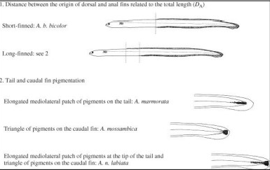

Appendix 3. Ege, (1939) Fin index identification key for tropical juvenile anguillid eels
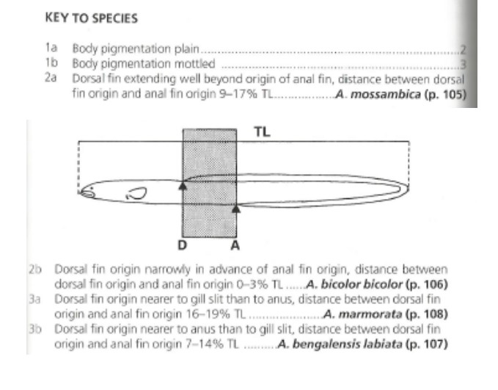

Appendix 4. FDI for every individual captured
 | Family | TL (cm) | DF to AF (mm) | LH (mm) | RH (mm) | Site | Total_Length | FDI | LH_Index | RH_Index
Anguilla mossambica | Anguillidae | 5.4 | 135.296 | 54.384 | 50.7730 | SBE2 | 54000 | 0.25054815 | 0.10071111 | 0.09402407
Anguilla bengalensis | Anguillidae | 5.3 | 102.019 | 72.547 | 64.6770 | SBE2 | 53000 | 0.19248868 | 0.13688113 | 0.12203208
Anguilla bengalensis | Anguillidae | 5.7 | 153.960 | 57.157 | 62.7070 | SBE4 | 57000 | 0.27010526 | 0.10027544 | 0.11001228
Anguilla marmorata | Anguillidae | 5.0 | 130.894 | 71.072 | 66.3740 | SBE4 | 50000 | 0.26178800 | 0.14214400 | 0.13274800
Anguilla mossambica | Anguillidae | 5.2 | 107.439 | 70.345 | 65.8150 | SBE4 | 52000 | 0.20661346 | 0.13527885 | 0.12656731
Anguilla mossambica | Anguillidae | 10.1 | 137.570 | 92.985 | 95.8040 | SBE3 | 101000 | 0.13620792 | 0.09206436 | 0.09485545
Anguilla bengalensis | Anguillidae | 5.6 | 109.694 | 68.126 | 66.5270 | SBE1 | 56000 | 0.19588214 | 0.12165357 | 0.11879821
Anguilla bengalensis | Anguillidae | 5.3 | 119.019 | 66.393 | 64.5830 | SBE2 | 53000 | 0.22456415 | 0.12526981 | 0.12185472
Anguilla mossambica | Anguillidae | 5.7 | 216.262 | 70.842 | 65.7850 | SBE3 | 57000 | 0.37940702 | 0.12428421 | 0.11541228
Anguilla mossambica | Anguillidae | 5.7 | 66.506 | 70.284 | 67.2570 | SBE4 | 57000 | 0.11667719 | 0.12330526 | 0.11799474
Anguilla bengalensis | Anguillidae | 5.5 | 112.257 | 68.994 | 65.6789 | SBE4 | 55000 | 0.20410364 | 0.12544364 | 0.11941618
Anguilla mossambica | Anguillidae | 4.9 | 90.696 | 62.796 | 61.2160 | SBE4 | 49000 | 0.18509388 | 0.12815510 | 0.12493061
Anguilla bengalensis | Anguillidae | 5.4 | 199.379 | 74.686 | 66.3740 | SBE2 | 54000 | 0.36922037 | 0.13830741 | 0.12291481
Anguilla bengalensis | Anguillidae | 5.3 | 117.628 | 67.894 | 63.9780 | SBE2 | 53000 | 0.22193962 | 0.12810189 | 0.12071321
Anguilla bengalensis | Anguillidae | 5.6 | 108.159 | 69.458 | 65.7480 | SBE3 | 56000 | 0.19314107 | 0.12403214 | 0.11740714
Anguilla mossambica | Anguillidae | 5.3 | 86.908 | 69.139 | 59.7150 | SBE3 | 53000 | 0.16397736 | 0.13045094 | 0.11266981
Anguilla bengalensis | Anguillidae | 4.9 | 114.303 | 67.289 | 57.1500 | SBE3 | 49000 | 0.23327143 | 0.13732449 | 0.11663265
Anguilla mossambica | Anguillidae | 5.3 | 48.365 | 63.479 | 59.0220 | SBE3 | 53000 | 0.09125472 | 0.11977170 | 0.11136226
Anguilla bengalensis | Anguillidae | 4.6 | 74.818 | 61.216 | 57.4780 | SBE1 | 46000 | 0.16264783 | 0.13307826 | 0.12495217
Anguilla bengalensis | Anguillidae | 5.3 | 123.955 | 69.561 | 55.9420 | SBE1 | 53000 | 0.23387736 | 0.13124717 | 0.10555094
Anguilla mossambica | Anguillidae | 5.1 | 157.948 | 64.305 | 66.6090 | SBE1 | 51000 | 0.30970196 | 0.12608824 | 0.13060588
Anguilla bengalensis | Anguillidae | 5.3 | 163.993 | 64.252 | 61.9720 | SBE1 | 53000 | 0.30942075 | 0.12123019 | 0.11692830
Anguilla bengalensis | Anguillidae | 4.9 | 114.110 | 80.276 | 81.6150 | SBE1 | 49000 | 0.23287755 | 0.16382857 | 0.16656122
Anguilla bengalensis | Anguillidae | 5.3 | 146.701 | 61.211 | 66.5190 | SBE2 | 53000 | 0.27679434 | 0.11549245 | 0.12550755
Anguilla bengalensis | Anguillidae | 5.4 | 93.101 | 61.986 | 64.3940 | SBE2 | 54000 | 0.17240926 | 0.11478889 | 0.11924815
Anguilla bengalensis | Anguillidae | 6.5 | 170.848 | 55.016 | 54.2630 | SBE2 | 65000 | 0.26284308 | 0.08464000 | 0.08348154
Anguilla mossambica | Anguillidae | 5.1 | 173.070 | 62.253 | 63.8420 | SBE2 | 51000 | 0.33935294 | 0.12206471 | 0.12518039
Anguilla bengalensis | Anguillidae | 5.2 | 108.862 | 67.295 | 60.4750 | SBE2 | 52000 | 0.20935000 | 0.12941346 | 0.11629808
Anguilla bengalensis | Anguillidae | 5.4 | 120.158 | 58.194 | 59.7430 | SBE4 | 54000 | 0.22251481 | 0.10776667 | 0.11063519
Anguilla bengalensis | Anguillidae | 5.2 | 151.903 | 61.967 | 57.5570 | SBE4 | 52000 | 0.29212115 | 0.11916731 | 0.11068654
Anguilla bengalensis | Anguillidae | 5.6 | 114.906 | 57.433 | 49.9680 | SBE4 | 56000 | 0.20518929 | 0.10255893 | 0.08922857
Anguilla mossambica | Anguillidae | 5.0 | 1400.568 | 398.128 | 398.0010 | SBE4 | 50000 | 2.80113600 | 0.79625600 | 0.79600200
Anguilla mossambica | Anguillidae | 11.0 | 507.831 | 94.483 | 103.1740 | SBE4 | 110000 | 0.46166455 | 0.08589364 | 0.09379455
Anguilla mossambica | Anguillidae | 9.8 | 322.101 | 107.988 | 102.7750 | SBE4 | 98000 | 0.32867449 | 0.11019184 | 0.10487245
Anguilla bengalensis | Anguillidae | 7.5 | 202.527 | 77.214 | 78.7230 | SBE2 | 75000 | 0.27003600 | 0.10295200 | 0.10496400
Anguilla bengalensis | Anguillidae | 5.2 | 152.000 | 63.897 | 58.8410 | SBE4 | 52000 | 0.29230769 | 0.12287885 | 0.11315577
Anguilla marmorata | Anguillidae | 5.4 | 119.394 | 57.892 | 58.6510 | SBE4 | 54000 | 0.22110000 | 0.10720741 | 0.10861296
Anguilla bengalensis | Anguillidae | 5.1 | 111.656 | 67.310 | 74.2280 | SBE4 | 51000 | 0.21893333 | 0.13198039 | 0.14554510
Anguilla bengalensis | Anguillidae | 5.1 | 113.351 | 61.820 | 70.0600 | SBE4 | 51000 | 0.22225686 | 0.12121569 | 0.13737255
Anguilla mossambica | Anguillidae | 5.1 | 203.128 | 63.609 | 65.4710 | SBE4 | 51000 | 0.39829020 | 0.12472353 | 0.12837451
Anguilla mossambica | Anguillidae | 7.3 | 234.271 | 77.096 | 65.2710 | SBE3 | 73000 | 0.32091918 | 0.10561096 | 0.08941233
Anguilla bengalensis | Anguillidae | 7.3 | 59.719 | 59.719 | 53.6760 | SBE3 | 73000 | 0.08180685 | 0.08180685 | 0.07352877
Anguilla mossambica | Anguillidae | 7.6 | 226.207 | 51.627 | 40.5680 | SBE3 | 76000 | 0.29764079 | 0.06793026 | 0.05337895
Anguilla bengalensis | Anguillidae | 6.8 | 105.586 | 58.079 | 55.3370 | SBE1 | 68000 | 0.15527353 | 0.08541029 | 0.08137794
Anguilla bengalensis | Anguillidae | 5.3 | 111.683 | 70.151 | 54.3920 | SBE1 | 53000 | 0.21072264 | 0.13236038 | 0.10262642
Anguilla mossambica | Anguillidae | 5.6 | 195.599 | 40.158 | 42.4110 | SBE1 | 56000 | 0.34928393 | 0.07171071 | 0.07573393
Anguilla mossambica | Anguillidae | 5.4 | 283.743 | 45.317 | 51.6190 | SBE1 | 54000 | 0.52545000 | 0.08392037 | 0.09559074
Anguilla mossambica | Anguillidae | 5.3 | 441.158 | 50.731 | 57.1790 | SBE1 | 53000 | 0.83237358 | 0.09571887 | 0.10788491
Anguilla bengalensis | Anguillidae | 5.0 | 269.606 | 45.176 | 42.4110 | SBE1 | 50000 | 0.53921200 | 0.09035200 | 0.08482200
Anguilla bengalensis | Anguillidae | 5.3 | 126.479 | 65.504 | 58.3740 | SBE1 | 53000 | 0.23863962 | 0.12359245 | 0.11013962
Anguilla bengalensis | Anguillidae | 5.5 | 211.489 | 62.680 | 54.3920 | SBE4 | 55000 | 0.38452545 | 0.11396364 | 0.09889455
Anguilla bengalensis | Anguillidae | 5.3 | 130.439 | 63.609 | 50.7060 | SBE4 | 53000 | 0.24611132 | 0.12001698 | 0.09567170
Anguilla bengalensis | Anguillidae | 5.4 | 104.209 | 57.157 | 52.5410 | SBE4 | 54000 | 0.19297963 | 0.10584630 | 0.09729815
Anguilla mossambica | Anguillidae | 7.4 | 176.840 | 86.269 | 72.5630 | SBE4 | 74000 | 0.23897297 | 0.11657973 | 0.09805811
Anguilla bengalensis | Anguillidae | 5.6 | 106.553 | 79.406 | 72.5470 | SBE4 | 56000 | 0.19027321 | 0.14179643 | 0.12954821
Anguilla bengalensis | Anguillidae | 4.8 | 115.632 | 59.777 | 61.2530 | SBE1 | 48000 | 0.24090000 | 0.12453542 | 0.12761042
Anguilla bengalensis | Anguillidae | 5.3 | 142.272 | 58.194 | 55.1710 | SBE1 | 53000 | 0.26843774 | 0.10980000 | 0.10409623
Anguilla bengalensis | Anguillidae | 5.4 | 83.142 | 61.972 | 63.5190 | SBE1 | 54000 | 0.15396667 | 0.11476296 | 0.11762778
Anguilla bengalensis | Anguillidae | 4.8 | 36.305 | 59.719 | 52.8990 | SBE2 | 48000 | 0.07563542 | 0.12441458 | 0.11020625
Anguilla bengalensis | Anguillidae | 5.5 | 170.059 | 59.700 | 57.8340 | SBE2 | 55000 | 0.30919818 | 0.10854545 | 0.10515273
Anguilla bengalensis | Anguillidae | 5.2 | 126.966 | 71.827 | 65.0300 | SBE2 | 52000 | 0.24416538 | 0.13812885 | 0.12505769
Anguilla bengalensis | Anguillidae | 5.4 | 123.944 | 68.831 | 73.3140 | SBE2 | 54000 | 0.22952593 | 0.12746481 | 0.13576667
Anguilla bengalensis | Anguillidae | 5.3 | 129.304 | 53.660 | 62.1930 | SBE1 | 53000 | 0.24396981 | 0.10124528 | 0.11734528
Anguilla bengalensis | Anguillidae | 5.0 | 102.019 | 67.410 | 64.3450 | SBE1 | 50000 | 0.20403800 | 0.13482000 | 0.12869000
Anguilla bengalensis | Anguillidae | 5.3 | 189.075 | 66.519 | 62.0090 | SBE2 | 53000 | 0.35674528 | 0.12550755 | 0.11699811
Anguilla mossambica | Anguillidae | 5.7 | 185.152 | 59.333 | 53.7400 | SBE4 | 57000 | 0.32482807 | 0.10409298 | 0.09428070
Anguilla bengalensis | Anguillidae | 5.6 | 137.545 | 64.252 | 64.2390 | SBE4 | 56000 | 0.24561607 | 0.11473571 | 0.11471250
Anguilla bengalensis | Anguillidae | 5.2 | 157.970 | 62.082 | 53.9940 | SBE2 | 52000 | 0.30378846 | 0.11938846 | 0.10383462
Anguilla bengalensis | Anguillidae | 5.4 | 56.723 | 37.037 | 31.8830 | SBE2 | 54000 | 0.10504259 | 0.06858704 | 0.05904259
Anguilla bengalensis | Anguillidae | 5.4 | 98.252 | 56.677 | 48.5120 | SBE3 | 54000 | 0.18194815 | 0.10495741 | 0.08983704
Anguilla bengalensis | Anguillidae | 5.6 | 77.096 | 54.494 | 55.4190 | SBE3 | 56000 | 0.13767143 | 0.09731071 | 0.09896250
Anguilla mossambica | Anguillidae | 5.4 | 77.841 | 50.722 | 50.6370 | SBE1 | 54000 | 0.14415000 | 0.09392963 | 0.09377222
Anguilla bengalensis | Anguillidae | 5.3 | 69.541 | 57.612 | 57.0840 | SBE1 | 53000 | 0.13120943 | 0.10870189 | 0.10770566
Anguilla bengalensis | Anguillidae | 5.3 | 82.402 | 55.927 | 42.3800 | SBE1 | 53000 | 0.15547547 | 0.10552264 | 0.07996226
Anguilla bengalensis | Anguillidae | 5.3 | 71.354 | 56.785 | 57.9320 | SBE1 | 53000 | 0.13463019 | 0.10714151 | 0.10930566
Anguilla bengalensis | Anguillidae | 5.4 | 116.380 | 60.498 | 54.5990 | SBE1 | 54000 | 0.21551852 | 0.11203333 | 0.10110926
Anguilla mossambica | Anguillidae | 5.4 | 135.296 | 54.384 | 50.7730 | SBE2 | 54000 | 0.25054815 | 0.10071111 | 0.09402407
Anguilla bengalensis | Anguillidae | 5.3 | 102.019 | 72.547 | 64.6770 | SBE2 | 53000 | 0.19248868 | 0.13688113 | 0.12203208
Anguilla bengalensis | Anguillidae | 5.7 | 153.960 | 57.157 | 62.7070 | SBE4 | 57000 | 0.27010526 | 0.10027544 | 0.11001228
Anguilla marmorata | Anguillidae | 5.0 | 130.894 | 71.072 | 66.3740 | SBE4 | 50000 | 0.26178800 | 0.14214400 | 0.13274800
Anguilla mossambica | Anguillidae | 5.2 | 107.439 | 70.345 | 65.8150 | SBE4 | 52000 | 0.20661346 | 0.13527885 | 0.12656731
Anguilla mossambica | Anguillidae | 10.1 | 137.570 | 92.985 | 95.8040 | SBE3 | 101000 | 0.13620792 | 0.09206436 | 0.09485545
Anguilla bengalensis | Anguillidae | 5.6 | 109.694 | 68.126 | 66.5270 | SBE1 | 56000 | 0.19588214 | 0.12165357 | 0.11879821
Anguilla bengalensis | Anguillidae | 5.3 | 119.019 | 66.393 | 64.5830 | SBE2 | 53000 | 0.22456415 | 0.12526981 | 0.12185472
Anguilla mossambica | Anguillidae | 5.7 | 216.262 | 70.842 | 65.7850 | SBE3 | 57000 | 0.37940702 | 0.12428421 | 0.11541228
Anguilla mossambica | Anguillidae | 5.7 | 66.506 | 70.284 | 67.2570 | SBE4 | 57000 | 0.11667719 | 0.12330526 | 0.11799474
Anguilla bengalensis | Anguillidae | 5.5 | 112.257 | 68.994 | 65.6789 | SBE4 | 55000 | 0.20410364 | 0.12544364 | 0.11941618
Anguilla mossambica | Anguillidae | 4.9 | 90.696 | 62.796 | 61.2160 | SBE4 | 49000 | 0.18509388 | 0.12815510 | 0.12493061
Anguilla bengalensis | Anguillidae | 5.4 | 199.379 | 74.686 | 66.3740 | SBE2 | 54000 | 0.36922037 | 0.13830741 | 0.12291481
Anguilla bengalensis | Anguillidae | 5.3 | 117.628 | 67.894 | 63.9780 | SBE2 | 53000 | 0.22193962 | 0.12810189 | 0.12071321
Anguilla bengalensis | Anguillidae | 5.6 | 108.159 | 69.458 | 65.7480 | SBE3 | 56000 | 0.19314107 | 0.12403214 | 0.11740714
Anguilla mossambica | Anguillidae | 5.3 | 86.908 | 69.139 | 59.7150 | SBE3 | 53000 | 0.16397736 | 0.13045094 | 0.11266981
Anguilla bengalensis | Anguillidae | 4.9 | 114.303 | 67.289 | 57.1500 | SBE3 | 49000 | 0.23327143 | 0.13732449 | 0.11663265
Anguilla mossambica | Anguillidae | 5.3 | 48.365 | 63.479 | 59.0220 | SBE3 | 53000 | 0.09125472 | 0.11977170 | 0.11136226
Anguilla mossambica | Anguillidae | 5.4 | 135.296 | 54.384 | 50.7730 | SBE2 | 54000 | 0.25054815 | 0.10071111 | 0.09402407
Anguilla bengalensis | Anguillidae | 5.3 | 102.019 | 72.547 | 64.6770 | SBE2 | 53000 | 0.19248868 | 0.13688113 | 0.12203208
Anguilla bengalensis | Anguillidae | 5.7 | 153.960 | 57.157 | 62.7070 | SBE4 | 57000 | 0.27010526 | 0.10027544 | 0.11001228
Anguilla marmorata | Anguillidae | 5.0 | 130.894 | 71.072 | 66.3740 | SBE4 | 50000 | 0.26178800 | 0.14214400 | 0.13274800
Anguilla mossambica | Anguillidae | 5.2 | 107.439 | 70.345 | 65.8150 | SBE4 | 52000 | 0.20661346 | 0.13527885 | 0.12656731
Anguilla mossambica | Anguillidae | 10.1 | 137.570 | 92.985 | 95.8040 | SBE3 | 101000 | 0.13620792 | 0.09206436 | 0.09485545
Anguilla bengalensis | Anguillidae | 5.6 | 109.694 | 68.126 | 66.5270 | SBE1 | 56000 | 0.19588214 | 0.12165357 | 0.11879821
Anguilla bengalensis | Anguillidae | 5.3 | 119.019 | 66.393 | 64.5830 | SBE2 | 53000 | 0.22456415 | 0.12526981 | 0.12185472
Anguilla mossambica | Anguillidae | 5.7 | 216.262 | 70.842 | 65.7850 | SBE3 | 57000 | 0.37940702 | 0.12428421 | 0.11541228
Anguilla mossambica | Anguillidae | 5.7 | 66.506 | 70.284 | 67.2570 | SBE4 | 57000 | 0.11667719 | 0.12330526 | 0.11799474
Anguilla bengalensis | Anguillidae | 5.5 | 112.257 | 68.994 | 65.6789 | SBE4 | 55000 | 0.20410364 | 0.12544364 | 0.11941618
Anguilla mossambica | Anguillidae | 4.9 | 90.696 | 62.796 | 61.2160 | SBE4 | 49000 | 0.18509388 | 0.12815510 | 0.12493061
Anguilla bengalensis | Anguillidae | 5.4 | 199.379 | 74.686 | 66.3740 | SBE2 | 54000 | 0.36922037 | 0.13830741 | 0.12291481
Anguilla bengalensis | Anguillidae | 5.3 | 117.628 | 67.894 | 63.9780 | SBE2 | 53000 | 0.22193962 | 0.12810189 | 0.12071321
Anguilla bengalensis | Anguillidae | 5.6 | 108.159 | 69.458 | 65.7480 | SBE3 | 56000 | 0.19314107 | 0.12403214 | 0.11740714
Anguilla mossambica | Anguillidae | 5.3 | 86.908 | 69.139 | 59.7150 | SBE3 | 53000 | 0.16397736 | 0.13045094 | 0.11266981
Anguilla bengalensis | Anguillidae | 4.9 | 114.303 | 67.289 | 57.1500 | SBE3 | 49000 | 0.23327143 | 0.13732449 | 0.11663265
Anguilla mossambica | Anguillidae | 5.3 | 48.365 | 63.479 | 59.0220 | SBE3 | 53000 | 0.09125472 | 0.11977170 | 0.11136226
Anguilla mossambica | Anguillidae | 5.4 | 135.296 | 54.384 | 50.7730 | SBE2 | 54000 | 0.25054815 | 0.10071111 | 0.09402407
Anguilla bengalensis | Anguillidae | 5.3 | 102.019 | 72.547 | 64.6770 | SBE2 | 53000 | 0.19248868 | 0.13688113 | 0.12203208
Anguilla bengalensis | Anguillidae | 5.7 | 153.960 | 57.157 | 62.7070 | SBE4 | 57000 | 0.27010526 | 0.10027544 | 0.11001228
Anguilla marmorata | Anguillidae | 5.0 | 130.894 | 71.072 | 66.3740 | SBE4 | 50000 | 0.26178800 | 0.14214400 | 0.13274800
Anguilla mossambica | Anguillidae | 5.2 | 107.439 | 70.345 | 65.8150 | SBE4 | 52000 | 0.20661346 | 0.13527885 | 0.12656731
Anguilla mossambica | Anguillidae | 10.1 | 137.570 | 92.985 | 95.8040 | SBE3 | 101000 | 0.13620792 | 0.09206436 | 0.09485545
Anguilla bengalensis | Anguillidae | 5.6 | 109.694 | 68.126 | 66.5270 | SBE1 | 56000 | 0.19588214 | 0.12165357 | 0.11879821
Anguilla bengalensis | Anguillidae | 5.3 | 119.019 | 66.393 | 64.5830 | SBE2 | 53000 | 0.22456415 | 0.12526981 | 0.12185472
Anguilla mossambica | Anguillidae | 5.7 | 216.262 | 70.842 | 65.7850 | SBE3 | 57000 | 0.37940702 | 0.12428421 | 0.11541228
Anguilla mossambica | Anguillidae | 5.7 | 66.506 | 70.284 | 67.2570 | SBE4 | 57000 | 0.11667719 | 0.12330526 | 0.11799474
Anguilla bengalensis | Anguillidae | 5.5 | 112.257 | 68.994 | 65.6789 | SBE4 | 55000 | 0.20410364 | 0.12544364 | 0.11941618
Anguilla mossambica | Anguillidae | 4.9 | 90.696 | 62.796 | 61.2160 | SBE4 | 49000 | 0.18509388 | 0.12815510 | 0.12493061
Anguilla bengalensis | Anguillidae | 5.4 | 199.379 | 74.686 | 66.3740 | SBE2 | 54000 | 0.36922037 | 0.13830741 | 0.12291481
Anguilla bengalensis | Anguillidae | 5.3 | 117.628 | 67.894 | 63.9780 | SBE2 | 53000 | 0.22193962 | 0.12810189 | 0.12071321
Anguilla bengalensis | Anguillidae | 5.6 | 108.159 | 69.458 | 65.7480 | SBE3 | 56000 | 0.19314107 | 0.12403214 | 0.11740714
Anguilla mossambica | Anguillidae | 5.3 | 86.908 | 69.139 | 59.7150 | SBE3 | 53000 | 0.16397736 | 0.13045094 | 0.11266981
Anguilla bengalensis | Anguillidae | 4.9 | 114.303 | 67.289 | 57.1500 | SBE3 | 49000 | 0.23327143 | 0.13732449 | 0.11663265
Anguilla mossambica | Anguillidae | 5.3 | 48.365 | 63.479 | 59.0220 | SBE3 | 53000 | 0.09125472 | 0.11977170 | 0.11136226

Appendix 4. Eye and Fin morphometrics of juvenile anguillid eels
